EMR HOSTING SPECIFICATION
SUBSTANTIATION REQUIREMENTS
EMR vendors MUST submit ALL the documentation as outlined in the table below with their Application for EMR Certification. EMR vendors MUST also submit a completed EMR Hosting Specification Reference Sheet, which accompanies this document on the OntarioMD website.

The documentation substantiates the EMR offering’s ability to meet the MANDATORY requirements in the EMR Hosting Specification on the OntarioMD website under Current EMR Specifications.

Failure to submit any of the documents could result in the Application for EMR Certification being incomplete.

Documentation Submission Requirements:

EMR Vendors MUST submit ALL Hosting Specification Documentation using file names and folder structure
which mirrors the Requirement Categories and Numbered Items below. See the below visual:

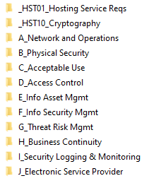

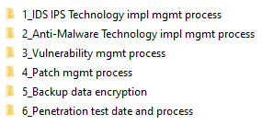

NOTE: Any Hosting Specification Documentation submission which does not conform to the requested file and
folder conventions and structure will NOT be reviewed further by OntarioMD; EMR Vendors will be notified
and advised to re-submit following the stated standard.

# | Requirement
A | Network and Operations  1. IDS / IPS Technology implementation and management process.  2. Anti-Malware technology implementation and management process.  3. Vulnerability Management process.  4. Patch Management process.  5. Provide information on how the backup data is encrypted and how the keys are managed.  6. Provide date of last penetration test and describe process
B | Physical security for the data centeR  1. Provide copy of SSA16 or SAS70 certification  2. Provide Visitor Policy documentation
C | Acceptable use of information and information technology  1. Provide Acceptable Use of Information and Information Technology documentation in support of the controls in this category
D | Access control and identity management for system level access (system administrators)  1. Provide background check policy  2. Provide Privileged ID management process document
E | Information asset management  1. Provide documentation for managing data disposal, removal or transport of media
F | information security incident management  1. Provide Security Incident Management documentation e.g. policy or procedure
G | threat risk management (system level)  1. Provide detailed policy / process of conducting Threat Risk Assessment, Risk Treatment Plan and maintenance of Risk Register  2. Provide most recent TRA summary report
H | business continuity (not system disaster recovery)  1. Provide Business Continuity Plan / processes
I | security logging and monitoring  1. Provide the Security Logging and monitoring process / procedure document (including roles & responsibilities, review frequency and response in case of alerts / anomalies)
J | Electronic service provider  1. Provide details on the agreement/service level agreements that the EMR vendor has with the data center provider

