OntarioMD Inc.

Hospital Report Manager

EMR Vendor Planning Guide

Version: 1.0
Date: August 15, 2013

Table of Contents
Hospital Report Manager 1
Table of Contents 2
1. About This Document 3
1.1. EMR Vendor Planning Guide Purpose 3
1.2. How to Use the Guide 3
2. HRM 4
2.1. HRM Product Overview 4
2.2. OntarioMD HRM Adoption Overview 5
3. HRM Deployment and Progress 6
3.1. Planning to Deploy HRM Functionality to Clients 6
3.2. HRM Information to Support EMR Vendor Planning 6
3.3. HRM Deployment Schedule 6
3.4. HRM Progress by EMR Vendor 6
4. EMR Vendor Activities for HRM Deployment 7
4.1. Prepare 7
4.1.1. HRM Welcome Package 7
4.1.2. HRM Implementation Checklist 7
4.2. Enroll 8
4.3. Implement 9
4.3.1. Connecting to HRM 9
4.3.2. OMD HRM Testing 10
4.3.3. Deliver HRM Product Training 12
4.3.4. Understand Workflow Changes 12
4.3.5. Report Categorization 12
4.3.6. Go-Live 12
4.4. Use 13
4.4.1. Stabilization Period & OntarioMD Monitoring 13
4.4.2. Discontinue Transmission of Reports Replaced by HRM 13
4.4.3. HRM Operational and Support Processes 13
5. Support and Information for EMR Vendors 14
Attachment A: HRM Adoption and Implementation Activities 15
Attachment B: Related Documents and References 16
Attachment C: GLOSSARY 17

About This Document

EMR Vendor Planning Guide Purpose
The EMR Vendor Planning Guide (“Guide”) will inform and prepare EMR Vendors about the Hospital Report Manager (HRM) implementation process defined by OntarioMD. The Guide is focused on the EMR Vendors activities and responsibilities to be completed with the Clinician Practices preparing to use HRM and assumes the EMR vendor has received Approval of the HRM functionality.
OntarioMD wants to partner and support EMR vendors for a smooth HRM implementation process, to ensure that clients with a Funding Eligible EMR Offering are successfully connected to HRM to meet Provincial deployment targets.
NOTE:
This Guide complements the HRM Reference Site Phase Guidelines for EMR vendors.
As well, Practices will have similar information provided in the Clinician Practice Planning Guide and the HRM IT Operations Guide.

How to Use the Guide
This Guide describes the role and responsibilities of the EMR Vendors throughout the deployment activities as defined in the OntarioMD Adoption Activities.
Throughout the Guide references will be made to supporting documentation available on the OntarioMD portal or may be provided to the EMR Vendor as outlined in Attachment B: Related Documents and References.

HRM

HRM Product Overview
HRM enables hospitals or Independent Health Facilities (IHFs) to electronically transmit patient reports to a clinician’s Electronic Medical Record (EMR) for inclusion in follow-up care. HRM replaces the existing process of sending paper copies, faxes to the clinician’s office and manual integration into the EMR. With the introduction of HRM, hospital reports are updated directly to the patient's EMR for a physician to access in a timely and less labour intensive manner.
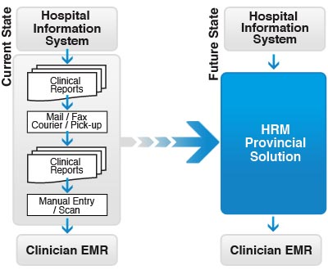
HRM electronically sends narrative, text-based Medical Record (MR) and Diagnostic Imaging (DI) reports directly into a patient's record into their clinician's EMR. The diagram below shows how HRM works.
The Hospital Information System sends a patient report to HRM using HL7.
HRM converts the patient report into the EMR standard message format, encrypts and stores the report in a sFTP folder for secure transmission to the intended funding eligible EMR Offering.
The EMR polls the HRM sFTP folder to retrieve the report(s), which is integrated into the patient's record and the clinician's inbox for review and sign-off.
For additional information about HRM refer to www.ontariomd.ca

OntarioMD HRM Adoption Overview
The HRM deployment process defined by OntarioMD for the Practice is broken out into four phases:
- Prepare,
- Enroll,
- Implement and
- Use
During the Prepare and Enroll phases, with the support of OntarioMD Field Staff, clinicians prepare for HRM deployment and register for HRM by signing legal agreements.
The Implement and Use phases include activities in the Practice that are completed in conjunction with OntarioMD IT Operations.
Throughout these phases, the EMR Vendor will have a role to support the Practice implement and start using HRM as outlined in the Summary of HRM Adoption Activities diagram below.
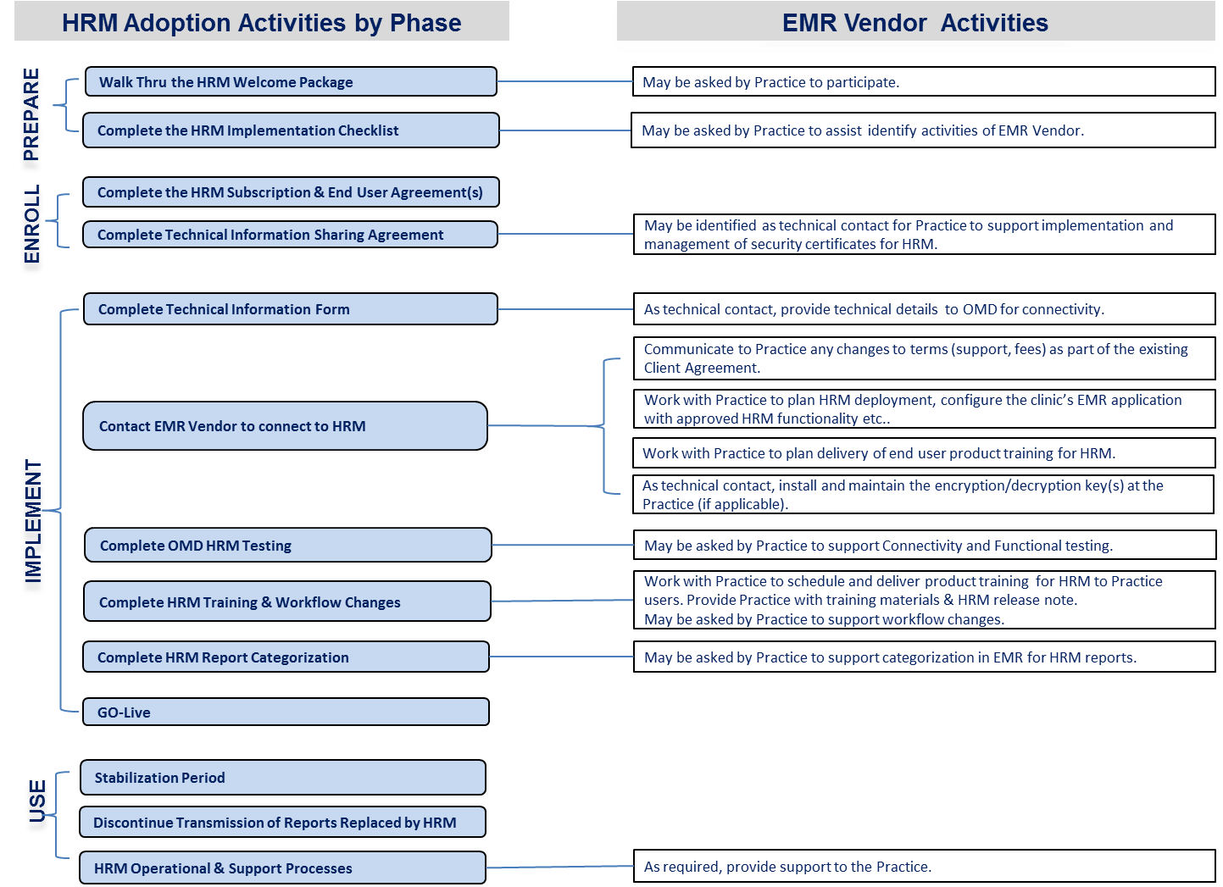
Diagram: Summary of EMR Vendor Activities
The activities included in the Summary are described with additional details in Section 4: EMR Vendor Activities for HRM Deployment, later in this document.

HRM Deployment and Progress

Planning to Deploy HRM Functionality to Clients
EMR vendors are required to deploy the HRM functionality (HRM release) to all clients/customers once the HRM functionality becomes generally available in a reasonable time.
Customers participating in Ontario’s EMR funding programs are obligated to upgrade their EMR when releases become Generally Available. All Customers must be notified by the EMR Vendor in writing (email acceptable) that the HRM release is Generally Available and the Vendor must schedule the upgrade date in consultation with the Customer. Coordinating deployment of HRM functionality along with other implementation activities for a Practice is encouraged where possible.
OntarioMD acknowledges each EMR vendors approach to deploy the HRM release across clients is distinct. The information described earlier in this section is meant to support your planning activities in support of your clients.

HRM Information to Support EMR Vendor Planning
OntarioMD is committed to connect 1,560 Physicians to HRM by March 2014. OntarioMD recognizes the important role of EMR vendors to achieve this commitment and will be assisting EMR vendors with information about HRM deployment across the Province that will inform planning activities.

OntarioMD will provide information about the broader Provincial deployment in addition to client level progress to inform EMR vendor planning of HRM release deployment and Client implementation of HRM.

HRM Deployment Schedule
OntarioMD will produce a deployment schedule on a monthly basis that identifies which sending facilities are targeted to come onboard and those that have gone live by LHIN. Initially this will be distributed via email.

HRM Progress by EMR Vendor
OntarioMD will produce a progress report by EMR Vendor to illustrate progress on key OntarioMD HRM Implementation milestones for the Practice/Clinician. The progress milestones illustrate progress against activities lead by OntarioMD. These milestones may be dependencies to activities of the EMR Vendor for the Practice.

HRM Progress Milestones
Which LHIN is a Practice in? | Filter list of Practices by LHIN
Is the sending facility the Practice wants to receive reports from live with HRM? | Reference HRM Deployment Schedule the status of a specific sending facility
Which Locations are actively preparing for HRM; signing the HRM Subscription Agreement is an indicator of this. | Status of HRM Subscription Agreement at Clinic Location is shown.
Have any Clinicians signed the HRM End User Agreement? | Status of HRM End User Agreement is shown.
HRM usage across Clinic Locations/Practices. | Status of Clinic Location being live/receiving HRM reports.

EMR Vendor Activities for HRM Deployment
Building on the Summary diagram in Section 2, the following will provide detailed information and context for EMR vendor activities throughout each of the OntarioMD defined HRM implementation phases.

Prepare

HRM Welcome Package
In the Prepare phase, Clinician Practices will be contacted by the OntarioMD Field Staff to provide information about getting connected to HRM.
The HRM Welcome Package has been prepared to walk clinicians through the activities required to be able to access HRM through their EMR system.
Note: The HRM Welcome Package is developed by OntarioMD.
EMR Vendor Involvement
- May be asked to participate in a walk-through of the HRM Welcome Package by the Practice.

HRM Implementation Checklist
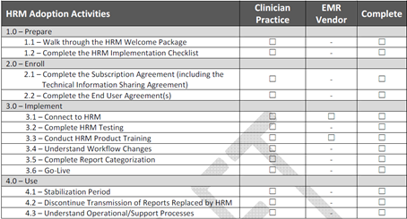
The HRM Implementation Checklist (Attachment A) provides the Practice a plan to coordinate activities required for HRM deployment in the following ways:
- Identify the available resources to assist with the HRM adoption project (i.e. internal resources, EMR Vendor, and 3rd party IT support).
- Identify the options on how the Practice resources can complete each activity and decide who is responsible for completing each activity.
- Assign a single point of contact from the practice to work with OntarioMD and other parties as required.
Note: The HRM Implementation Checklist is developed by OntarioMD

EMR Vendor Involvement
- Work with the Practice to identify EMR vendor activities, as requested by the Practice.

Enroll
During the Enroll phase, the clinicians and the HIC at the Practice will be required to sign one or more of the following:
Practice/Clinician Agreements:
- HRM Subscription Agreement – one per Practice. The HRM Subscription Agreement details the service being offered by OntarioMD, the obligations under PHIPA of the receiving Practice and the associated Service Level Agreement between the subscriber and OntarioMD.
- HRM End User Agreement – one per clinician receiving HRM reports. The End User Agreement is the document that has to be signed by each provider willing to enroll in HRM.
- Technical Information Sharing Agreement (Schedule B) – one per Practice.
The Technical Information Sharing Agreement:
- is the formal acknowledgement by the Health Information Custodian (HIC) at the Practice permitting OntarioMD to gather and use key technical information
- is the form to identify and permission to communicate with the contact identified as required and/or requested by the Practice for the purpose of connection to HRM
The contact identified in the Technical Information Sharing Agreement (Schedule B) can be one of the:
- HIC at the Practice,
- EMR Vendor, or
- third-party IT Provider
Reminder:
When the EMR vendor is not identified as the contact on the Technical Information Sharing Agreement the EMR Vendor should have the Practice declined this service in writing.
Conversely, when the EMR vendor is identified as the contact on the Technical Information Sharing Agreement the EMR vendor should obtain from the Practice confirmation they require the services in writing.
Note: The HRM Subscription Agreement, Technical Information Sharing Agreement (Schedule B) and the HRM End User Agreement are developed by OntarioMD.
EMR Vendor Involvement
- Provide assistance to complete the Technical Information Sharing Agreement (Schedule B) as required by the Practice.

Implement

Connecting to HRM

For ASP Vendors: this document assumes the ASP EMR vendor has signed the HRM Value Add Agreement with OntarioMD prior to participate in the activities to connect Practices to HRM.

Planning to Implement HRM at the Clinician Practice
The Practice is responsible to ensure the activities outlined in the HRM Implementation Checklist are completed. For each Practice the participants and activities of the EMR vendors will vary.
When the Practice identifies the EMR vendors as their contact on the Technical Information Sharing Agreement their involvement will require additional activities related to getting the Practice connected to HRM including:
- OntarioMD will contact and send the Technical Information Form; which is the mechanism to obtain the technical details about the EMR system required to establish a connection between the Practice’s EMR and HRM.
Note: The Technical Information Form is developed by OntarioMD.
The Practice will need to advise OntarioMD of the status of their EMR system:
- upgrade with HRM functionality is complete; and has been enabled to support connecting to HRM
OR
- working with their EMR vendor to upgrade EMR system and enable HRM

EMR Vendor Involvement
The following assumes the EMR vendor is the contact on the Technical Information Sharing Agreement:
- Will receive the Technical Information Form from OntarioMD; complete the form and submit as per information provided in the Form.

As well the following activities must be planned and completed:
- Communicate any changes to the Practice about their existing EMR support and or fees based on providing the support services to manage the security keys and certificates.
- Upgrade, configure the EMR system with the approved HRM functionality.
- Plan and deliver HRM product training.
- Verify the EMR system is ready to connect to HRM.

Connecting HRM to the Clinician Practice’s EMR
Once the Practice advises OntarioMD they are ready to connect, OntarioMD will send the HRM encryption/decryption key(s) to the HIC at the Practice or to the ASP vendor. It is the responsibility of the HIC to ensure the keys are installed unless the Practice declines this service from the EMR vendor.
According to PHIPA, once generated, the HRM encryption/decryption key can only be sent to:
- Local Offerings: the HIC at the Practice
- ASP Offerings: to the EMR vendor

OntarioMD will send a zipped and encrypted file containing the HRM encryption/decryption key(s) along with instructions about who to call to obtain the password to decrypt the zipped file:
Local EMR Offering:
- the appointed HIC at the Practice which will receive the keys
- in the instance where the HIC has appointed a contact on the Technical Information Sharing Agreement; the HIC is responsible to provide the keys and password to the contact
ASP EMR Offering:
- the appointed contact by the EMR Vendor will receive the encryption/decryption key(s)
EMR Vendor Involvement
The following assumes the EMR vendor is the contact on the Technical Information Sharing Agreement:
EMR Vendor with Local EMR Offering:
- Install and maintain the encryption/decryption key(s) at the Practice
- Advise the Practice the EMR is connected to HRM
EMR Vendor with ASP EMR Offering:
- Install and maintain the encryption/decryption keys as per the HRM Value Add Agreement and the EMR vendors support agreement with the Practice
- Advise the Practice the EMR is connected to HRM

OMD HRM Testing
OntarioMD will be conducting HRM Testing following the Practice verifying the successful installation of the encryption/decryption keys.
The Practice is responsible to ensure the following testing activities are complete; and may request the EMR vendor’s participation.
The key testing activities are anticipated to take two weeks:
- Connectivity testing; tests the ability of the EMR at Practice (production and/or test environment) to establish connectivity with HRM Test Environment
- Functional testing of the HRM at the Practice (production or test environment)
OntarioMD will work with the Practice and guide the Practice through the testing activities as follows:
Connectivity Testing: (will be conducted in the Practice Test Environment where possible)
- Practice receives the “Connectivity Quick Reference Guide” which contains information required for the Practice to establish a connection to the HRM Test Environment (where applicable).
  - Included is a “Form” to be completed and returned to OntarioMD by email.
- Practice completes the “Form” and submits to OntarioMD at: hrm.support@ontariomd.com
- OntarioMD receives the “Form” and validates the Practice’s connection to the HRM Test Environment
Functional Testing: (will be conducted in the Practice Test Environment where possible)
- Practice receives the ``Functional Testing Toolkit`` which contains:
- HRM pre-load test data – the test data to be entered into the EMR at the Practice to be able to review the required test cases
- HRM functional testing worksheet – the list of test cases for the Practice to perform
- OntarioMD will schedule a date to begin testing with the Practice.
- OntarioMD and the Practice and/or an EMR Vendor delegate will perform the connectivity and the functional testing.
- Practice will notify OntarioMD the testing was successful; submit confirmation by emailing hrm.support@ontariomd.com.
Once the Practice confirms the testing was successful the Practice is ready to connect to the HRM Provincial Environment.
The outcome of the functional testing might result in feedback from the Practice to the EMR Vendor.
Note: The Connectivity Quick Reference Guide and Functional Testing Toolkit are developed by OntarioMD.
EMR Vendor Involvement
- May be asked to support the Practice perform the HRM connectivity and functional testing and the activities with OntarioMD as defined above.

Deliver HRM Product Training
The Practice’s HRM Administrator and the EMR End Users are trained in administering the clinic’s EMR interface to HRM and managing the received HRM reports.
EMR Vendor Involvement
- Work with the Practice to define the training schedule.
- Deliver training to the Practice.
- Ensure the Practice receives access to the updated End User Materials.
- Ensure the Practice receives the Release Notes that include the HRM functionality.

Understand Workflow Changes
OntarioMD will support the Practice to conduct a review of their existing workflow(s) around inbound hospital report handling and to design/create the new workflow to accommodate the changes generated by receiving hospital reports electronically via HRM.
EMR Vendor Involvement
- Provide assistance for the purpose of introducing the new workflow(s) around received HRM reports as required by the Practice.

Report Categorization
The EMR must be set up with the HRM report categories as defined by the practice.
It is mandatory that the categorization of these reports is set-up prior to going live with HRM to ensure the reports are grouped in a meaningful way to the Practice.
Note: The comprehensive list of reports for each sending facility (hospital) will be published on the OntarioMD website (for url refer to Attachment B: Related Document & References).
The Practice will receive a list of reports for the first hospital the Practice will be connecting to through HRM.
EMR Vendor Involvement
- Provide assistance with the HRM report categorization when required by the Practice.

Go-Live
The EMR system at the Practice is ready to Go Live once all of the required activities have been completed and the Practice is connected to the HRM Provincial Environment and has started receiving HRM reports.
EMR Vendor Involvement
- Support Practice as required.
- Be prepared to support your role as part of the HRM Incident reporting processes; refer to Section 4.4.3 below and to the HRM Operations Support Guide.

Use

Stabilization Period & OntarioMD Monitoring
OntarioMD will support the Practice for a period of 4 weeks after Go Live during the Stabilization Period. During this time the Practice will be receiving hospital reports through HRM as well as the traditional methods.
OntarioMD will monitor the reports being sent from the hospital against the reports received via HRM at the Practice and share the findings with the Practice.
The purpose of the Stabilization Period is to:
- Validate that the HRM application at the Practice is functioning as expected.
- Ensure that if anything happens with a report(s) received via HRM, the Practice still receives the hospital report through the original means (eg. email, fax, etc.).
By the end of the Stabilization period, the Practice should be able to determine whether or not they are ready to discontinue the transmission of reports from the hospital that are now received via HRM.
EMR Vendor Involvement
- None anticipated

Discontinue Transmission of Reports Replaced by HRM
During this activity, depending on the outcome of the Stabilization Period, the Practice may choose to discontinue the transmission of the hospital reports using the old transmission methods (fax, mail, etc) on a clinician-by clinician basis.
EMR Vendor Involvement
- None anticipated

HRM Operational and Support Processes
OntarioMD and eHealth Ontario have developed an Operational Support Guide to assist the Practice with incident management.
HRM operational support processes may involve the EMR Vendor in addition to the eHealth Ontario Service Desk.
The following table outlines sample incidents that may require EMR vendor support:
# | INCIDENT
1 | Expected report not received
2 | Report cannot be opened/viewed
3 | Duplicate report(s) received
4 | Report sent cannot be consumed by EMR (error)

EMR Vendor Involvement
- The EMR vendor may be required to determine whether the reported incident is an issue that must be escalated to the eHealth Ontario Service desk.

Support and Information for EMR Vendors
If you have any questions, please contact OntarioMD at emr@ontariomd.com.
Additional information about HRM is available on the OntarioMD website including:
- General and Deployment information
- HRM Deployment Schedule
- HRM – Operation User Guide
- HRM – Vendor Planning Guide
- HRM – Reference Site Guidelines
- HRM – Readiness Reports by LHIN
- FAQ for Practices
- FAQ for EMR Vendors

Information that will be provided on an EMR vendor basis:
- HRM Progress by EMR Vendor

Attachment A: HRM Adoption and Implementation Activities

HRM Adoption Activities | Person | Clinician Practice | EMR Vendor | Completed on Date
 | Responsible
1.0 – Prepare
1.1 – Walk through the HRM Welcome Package
1.2 – Complete the HRM Implementation Checklist
2.0 – Enroll
2.1 – Complete the Subscription Agreement (including the Technical Information Sharing Agreement) |  |  | *
2.2 – Complete the End User Agreement(s) |  |  | -
3.0 – Implement – Go-live target identified in the beginning
3.1 – Connect to HRM
3.2 – Complete HRM Testing |  |  |  *
3.3 – Conduct HRM Product Training
3.4 – Understand Workflow Changes |  |  | -
3.5 – Complete Report Categorization |  |  | *
3.6 – Go-Live |  |  | -
4.0 – Use
4.1 – Stabilization Period |  |  | *
4.2 – Discontinue Transmission of Reports Replaced by HRM |  |  | -
4.3 – Understand Operational/Support Processes |  |  | -

Note: * Optional

Attachment B: Related Documents and References
The following table lists all documents related to, or referenced by the HRM –Vendor Planning Guide document.
DOCUMENT NAME | VERSION / DATE | DESCRIPTION | LOCATION*
Clinician Practice Planning Guide | N/A | A guide to the Clinician Practice to help the Practice prepare and adopt HRM effectively. | OntarioMD website*
Operation User Guide | TBP | A guide to HRM operation processes, roles and responsibilities and related activities to aid HRM users with ongoing use and management of the HRM. | OntarioMD website*
HRM Fact Sheet | TBP | An overview that briefly describes the HRM functionality and benefits and shows how HRM enables hospitals to send select patient reports to your EMR. | OntarioMD website*
HRM Physician FAQs | TBP | A compilation of frequently asked questions about HRM. | OntarioMD website*
Hospital Report Type List | TBP | The list of report types that will be sent electronically from each hospital involved in the project. | OntarioMD website*
Appendix F – Hospital Report Manager Requirements | v4.1A/  March 8, 2013 | This document defines requirements to be implemented into the EMR Offerings in order to interface with the OntarioMD- Hospital Report Manager (HRM) and process the downloaded hospital reports. | https://www.ontariomd.ca/idc/groups/public/documents/omd_file_content_item/omd012482.pdf
Appendix H - Additional Requirements | v4.1A/  March 8, 2013 | This document defines certain additional requirements to be observed by the Vendor in each of its EMR Offerings in order to provide additional certainty for physicians relating to EMR Offering initial implementation, upgrades and service level agreements under Ontario’s EMR Funding Programs. | https://www.ontariomd.ca/idc/groups/public/documents/omd_file_content_item/omd012482.pdf
HRM Deployment Schedule | Monthly | Refer to section 3.3 | Individual schedule by vendor
HRM Progress by EMR Vendor | TBP | Refer to section 3.4 | Individual progress by vendor

Note: * Intended Location

Attachment C: GLOSSARY

TERM | MEANING
Clinician Practice | The Clinician Practice is referenced throughout the current document as “Practice”.
CDS - XSD Schema | The xml data structure used to transport patient medical data for a single instance of an EMR that is used by one or more physicians in a primary care medical practice.
DI | Diagnostic Imaging
EMR Offering | The combination of EMR software, services, and support offered by a vendor.
HIC | Health Information Custodian
HRM Reports | The hospital reports that are downloaded from HRM system (sFTP server) in xml format compliant with HRM – XSD Schema
HRM | OntarioMD Hospital Report Manager System  The OntarioMD integration engine that enables the electronic transmission of patient text based report from a hospital (or other facilities) to their practice-based EMR’s providers.
HRM – XSD Schema | The xml data structure used to transport HRM reports from HRM system to EMR Offerings.
IHF | Independent Health Facilities
MR | Medical Record
OMD | OntarioMD Inc., a wholly owned subsidiary of the Ontario Medical Association.
XML | Extensible Mark-up Language.  A set of rules for encoding documents in machine-readable form.
XSD Schema | An XML-based language used to describe and control XML

