Health Report Manager (HRM)
Input Specification v0.5

Contents
1. Introduction 5
1.1. Who Should Use This Document 5
1.2. What is HRM? 5
2. Technical Overview 6
2.1. Background 6
2.1.1. HRM Testing Environment (UAT) 6
2.1.2. HRM Production Environment 6
3. Scope of Data 7
3.1. Scope of Data 7
3.2. Report Workflow 7
4. Message Structure 8
4.1. Message Format 8
4.2. General Structure 8
5. Message Definitions 9
5.1. How to Read this Section 9
5.1.1. Resource Tables 9
5.1.2. Data Type Tables 9
5.2. Bundle 11
5.2.1. entry 11
5.2.2. resource 12
5.3. Message Header 13
5.3.1. Event.coding 13
5.3.2. Source 14
5.3.3. Destination 14
5.4. Patient 15
5.4.1. Identifier 17
5.4.2. Identifier.Extension 17
5.4.2.1. Identifier.Type.coding 18
5.4.3. Name 18
5.4.4. Telecom 18
5.4.5. Gender 19
5.4.6. Birth Date 19
5.4.7. Deceased Boolean 19
5.4.8. Deceased Date Time 19
5.4.9. Address 19
5.5. Diagnostic Order 21
5.5.1. Orderer 21
5.5.2. Identifier 22
5.5.2.1. Identifier.Type.coding 22
5.6. DiagnosticReport 23
5.6.1. Extension 25
5.6.2. Identifier 25
5.6.2.1. Identifier.Type.coding 25
5.6.3. Status 26
5.6.4. Category.Coding 26
5.6.5. Code.Coding 26
5.6.6. EffectiveDateTime 26
5.6.7. Issued 27
5.6.8. Performer 27
5.6.9. Request 27
5.6.10. Conclusion 27
5.6.11. CodedDiagnosis.Coding 27
5.7. Document Manifest 29
5.7.1. Recipient 30
5.7.2. Author 30
5.7.3. Status 30
5.7.4. Content.pAttachment 30
5.7.5. Related.Ref 31
5.8. Encounter 32
5.8.1. Identifier 32
5.8.1.1. Identifier.Type.coding 33
5.8.2. Status 33
5.8.3. Class 33
5.8.4. Period 33
5.9. Practitioner 34
5.9.1. Identifier 34
5.9.1.1. Identifier.Type.coding 35
5.9.2. Name 35
6. Response Messages 36
6.1. Bundle 36
6.1.1. entry 37
6.1.2. resource 37
6.2. Message Header 38
6.2.1. Id 39
6.2.2. Timestamp 39
6.2.3. Event.coding 39
6.2.4. Response 39
6.2.4.1. Response.details 39
6.2.5. Source 39
6.2.6. Destination 40
6.2.6.1. Destination.Target 40
6.3. Operation Outcome 41
6.3.1. issue 41
6.3.1.1. issue.details 41
7. Message Example 42
8. Code Tables 47
Table 0001 – Event Code 47
Table 0002 – Identifier Use 48
Table 0003 – Identifier Type Codes 48
Table 0004 – Contact Point System 49
Table 0005 – Contact Point Use 49
Table 0006 – Administrative Gender 49
Table 0007 – Address Use 50
Table 0008 – Address Type 50
Table 0009 – Diagnostic Report Status 50
Table 0010 – Diagnostic Report Category 51
Table 0011 – Encounter Status 52
Table 0012 – Encounter Class 52
Table 0013 – Practitioner Role 53
Table 0014 – Assigning Authority 53
Table 0015 – DocumentManifest Status 54
Table 0016 – Address State 54
Table 0017 – Physician Systems 55
Table 0018 – Countries 56
Table 0019 – Document MIME types 56
Table 0020 – Health Card Provincial Systems 56
Table 0021 - Special Rules 57
Table 0022 – Response Codes 57
Table 0023 – Issue Severity 58
Table 0024 – Issue type 58

Introduction

Who Should Use This Document
This document outlines the input specification to enable the distribution of reports through Health Report Manager (HRM).
This is a technical specification document, intended to be read by clinical system administrators and interface developers who are building interfaces for the purpose of transmitting reports through HRM.

What is HRM?
HRM is an eHealth solution that enables clinicians using an OntarioMD-certified EMR to securely receive patient reports electronically from participating hospitals and specialty clinics.
Traditionally, hospitals and specialty clinics have sent reports to primary care providers and specialists by producing a paper document and sending by mail, fax or courier, or holding it for pick-up by clinicians. HRM electronically delivers the following report types from the hospital or specialty clinic directly into a patient’s record, within the clinician’s EMR:
- Medical Record (e.g. Discharge Summary)
- Diagnostic Imaging (excluding image)
- eNotifications – near real-time messages to notify them when their patients are discharged from the Emergency Department or are admitted or discharged from in-patient units.
The diagram below shows how HRM works:
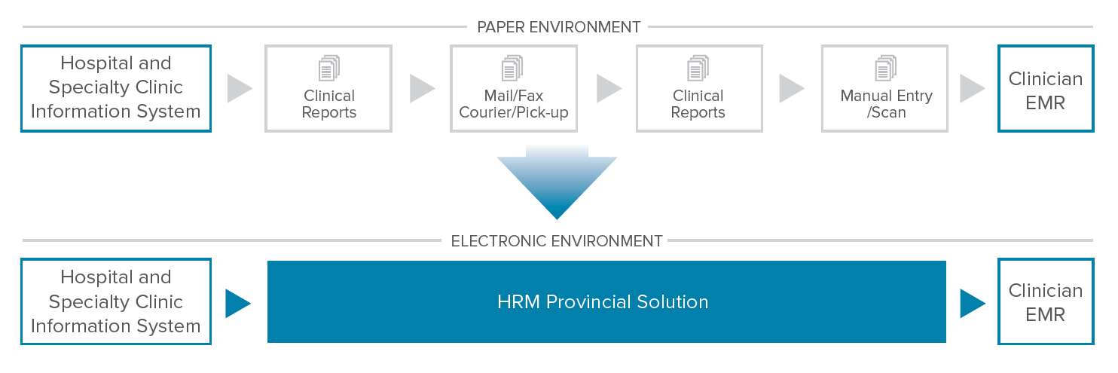
- The health information system (HIS) sends a patient report to the Health Report Manager using HL7 (a comprehensive framework and related standards for the exchange, integration, sharing, and retrieval of electronic health information that supports clinical practice and the management, delivery and evaluation of health service)
- HRM converts the patient report into the EMR standard message format, encrypts and stores the report in a Secure File Transfer Protocol (sFTP) folder for secure pickup by the intended OntarioMD-certified EMR
- The clinician’s EMR picks up the report, which is posted to the patient’s record and the clinician’s inbox for review and sign-off

For more information about HRM, please visit the OntarioMD website.

Technical Overview

Update: Request connectivity details from eHealth

Background
HRM is typically deployed in two possible configurations. The single facility direct connection or the hub and spoke model. In both cases there is a single connection to the HRM solution from the SF’s main site to dedicated HRM ports. Connectivity Requirements
OntarioMD Maintains two separate environments utilized for SF integrations. Connectivity to HRM is provisioned through dedicated SF ports within the HRM solution. It is highly recommended that SF maintain a separation between their testing and production systems to ensure no cross contamination occurs.

HRM Testing Environment (UAT)
  - Non-PHI
  - Address: https://wsgateway.pst.ehealthontario.ca:9443/ API/FHIR/HRM/v1

HRM Production Environment
  - Address: https://wsgateway.prod.ehealthontario.ca:9443/ API/FHIR/HRM/v1

Scope of Data

Scope of Data
The HRM solution supports text-based Medical Record (MR) and Diagnostic Imaging (text only) reports.

Examples include:
Medical Records: | Diagnostic Imaging (text only):
Ambulatory Note | BMD Transcription
Consultation Note | Mammogram
Discharge Summary | CT Transcription
Emergency Department Reports | Radiology Transcription
Cardiovascular Reports | Respiratory Reports

An HL7 data feed containing these clinical data types as well as any other clinical observations that would be considered useful to clinicians should be transmitted to HRM.

Report Workflow

To Do: Update with Product Team material

Message Structure

Message Format
Faster Healthcare Interoperability Resources (FHIR®) is a standards framework developed by HL7. It is fast and easy to implement, and allows electronic health information systems to speak to one another. More information of FHIR® standards can be found on their website.

General Structure

 | Message Header | The header for a message exchange that is either requesting or responding to an action.
 | Patient | The patient resource captures demographics and other administrative information about the individual receiving care or other health-related services.
 | Diagnostic Order | A Diagnostic Order is a record of a request for a set of diagnostic investigations to be performed.
 | Diagnostic Report | The Diagnostic Report contains the findings and interpretation of diagnostic tests performed on patients. The report includes clinical context such as requesting and provider information, and some mix of atomic results, images, textual and coded interpretations, and formatted representation of diagnostic reports
 | Document Manifest | The document manifest resource defines a set of documents.
 | Encounter | An interaction between a patient and healthcare provider(s) for the purpose of providing healthcare service(s) or assessing the health status of a patient.
 | Practitioner | A person who is directly or indirectly involved in the provisioning of healthcare.

Message Definitions

How to Read this Section

Resource Tables
The following columns are found within each resource table:
- Element Name: Identifies the FHIR component
- Cardinality (Card.): Indicates the optionality of the field. The following values may be found:

Value | Description
R (1) | Required. A value must always be provided
0 (0..1) | Optional. Systems should transmit data in this field if they support it, but this is not required.
C | Conditionally required please see Description
CH | Choice of either field, however, at least one must be present.

- Type: Indicates the FHIR data type associated with this field
- RP#: Indicates whether the field may repeat, and if so, indicates the minimum and maximum number of repetitions
- Len: Maximum length of the field if one is defined.
- Code Table#: Indicates that there is a specific value or rule set applicable to the field. Please reference the associated Code table in the appendix for rules or acceptable values.
- Description: Contains a description of the field

Data Type Tables
The following columns are found within each data type table:
 | Element Name | Identifies the data type
 | Card. | Indicates the cardinality of the field
 | Type | Indicates the FHIR data type associated with this field
 | Len | Indicates the maximum length of the field
 | Code Tbl# | For components where a code is expected a table is referenced in Section 7 that outlines from which values the data must be drawn
 | Sample Data | Shows an example of the data that may be found in this field

Bundle
The message bundle is the root of all messages to which all resources link up. The context specific resources are maintained under the entry-resource sub elements and are discussed as separate sections below.

Element Name | Card | Type | RP# | Len | Description | Sample Data
Bundle | R | DomainResource | - | - | Contains a collection of resources  entry
Id | R | id | 1 | 64 | Unique Bundle ID | PKG1-UC1-2-1
Type | R | Code | 1 | - | Bundle type. Default: message | message
entry | R | BackboneElement | 7..* | - | Entry in the bundle - will have a resource, or information  must be a resource unless there's a request or response
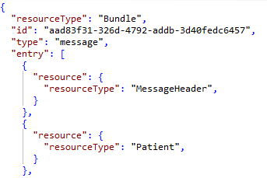

entry
The entry element is a repeating element which can contain only a single resource element and subsequent FHIR resource structure below. The possible sub elements are constrained to HRM FHIR specific elements only. All sub elements must exist within the message at least once and full definitions can be found in subsequent sections of this document.

Element Name | Card | Type | RP# | Len | Description | Sample Data
entry |  | BackboneElement | 7..* | - | Contains a collection of resources entry. The minimum number of repetitions is 7 with the expectation of at least 1 of each subelement
resource | R | Resource | 1 | - | Entry in the bundle - will have a resource, or information  must be a resource unless there's a request or response  The minimum number of repetitions is 7 with the expectation of at least 1 of each subelement | “resourceType”:”MessageHeader”

resource
The resource element is the parent to all FHIR resources contained within the message bundle and must contain a minimum of 1 instance of each. The available FHIR resources are as follows:

ResourceTypes | RP# | Description
MessageHeader | 1..1 | Data related to the message exchange
Patient | 1..1 | Patient identification and demographic data.
DiagnosticOrder | 1..1 | Ordering information related to the report data contained within the message.
DiagnosticReport | 1..1 | Report related discrete data elements
DocumentManifest | 1..1 | Report related attachments. (can be text or binary but must be base64 encoded)
Encounter | 1..1 | Information related to the encounter or visit associated with the message.
Practitioner | 1..* | Identification data related to clinicians referenced within the message, including recipients.

Message Header
MessageHeader is the header for a message exchange that is either requesting or responding to an action. The reference(s) that are the subject of the action as well as other information related to the action are typically transmitted in a bundle in which the MessageHeader resource instance is the first resource in the bundle. The tables below define the various data elements that should be provided within the Message Header.

Element Name | Card. | Type | RP# | Len | Code Tbl# | Description | Sample Data
MessageHeader |  |  |  |  |  | A resource that describes a message that is exchanged between systems
id | R | Id | 1 | 64 | - | Unique Message Header ID.  This is utilized as the Message Control ID and will be used as the identifier in the message response | aad83f31-326d-4792-addb-3d40fedc6457
timestamp | R | instant | 1 | - | 0021 | Time that the message was sent from the originating system to HRM. | 2017-01-09T11:36:55-05:00
event | R | Coding | 1 | - | - | Code for the event this message represents
source | R | BackboneElement | 1 | - | - | Message Source Application
destination | R | BackboneElement | 1 | - | - | Message Destination Application(s)
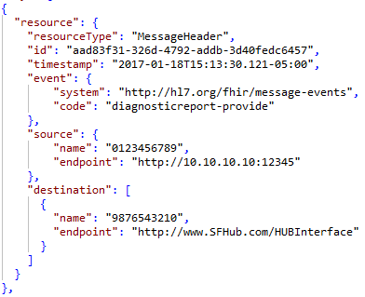

Event.coding
This field must contain the code for the event this message represents. For HRM purposes only “diagnosticreport-provide” events should be sent for report delivery.

Name | Card. | Type | RP# | Len | Code Tbl# | Description | Sample Data
Event.Coding | R | Element
system | R | uri | 1 | - | - | Code system used for the event coding. This is a fixed value. | http://hl7.org/fhir/message-events
code | R | code | 1 | - | 0001 | Message event code as referenced for the system. HRM currently only supports a single value of diagnosticreport-provide currently. | diagnosticreport-provide

Source
The sending facility for HRM is the legal HSP that takes full responsibility for sending the message. The source for this unique identifier is the Provider Registry number assigned to your facility by eHealth Ontario.

Name | Card. | Type | RP# | Len | Code Tbl# | Description | Sample Data
Source | R | Element
name | R | string | 1 | 12 | - | UPI identifier for the original system of the message | 1234567890
endpoint | R | uri | 1 | - | - | URL endpoint for the source of the message | http://10.10.10.10:12345  OR  http://www.sendingfacility.com/HIS

Destination
The purpose of this segment is to denote the intermediary system and destination application which the message is intended. OntarioMD will inform your sending facility what to populate this field with.

Name | Card. | Type | RP# | Len | Code Tbl# | Description | Sample Data
Destination | R | Element
name | R | string | 1 | 12 | - | UPI identifier for the system this message was original sent too. This can be either an intermediate system (HUB) or directly to HRM. | 1234567890  OR  HRM
endpoint | R | uri | 1 | - | - | URL endpoint for the destination. | http://www.SFHub.com/HubInterface  OR  http://www.ontariomd.com/HRM

Patient
The patient resource captures demographics and other administrative information about an individual receiving care or other health-related services.

Element Name | Card | Type | RP# | Len | Code tbl# | Description | Sample Data
Patient |  | DomainResource
id | R | Id | 1 | - | - | Internal identifier used within the message as a reference to other resources. This must be unique per resource type. | Patient001
identifier | R | Identifier | 1..2 | - | - | An identifier(s) for this patient
name | R | HumanName | 1 | - | - | A name associated with the individual.
telecom | O | ContactPoint | 0..5 | - | - | A telephone number by which the individual may be contacted
gender | R | code | 1 | - | 0006 | The gender that the patient is considered to have for administration and record keeping purposes | Male
birthDate | R | date | 1 | - | - | The date of birth for the individual | 1945-11-11
deceasedBoolean | CH | boolean | 1 | - | - | Indicates if the individual is deceased or not | false
deceasedDateTime |  | dateTime | 1 | - | 0021 | To be included if the patient is deceased and the date/time of death is known. | 2017-01-01T12:34:56-05:00
address | O | Address | 0..1 | - | - | Home address for the individual
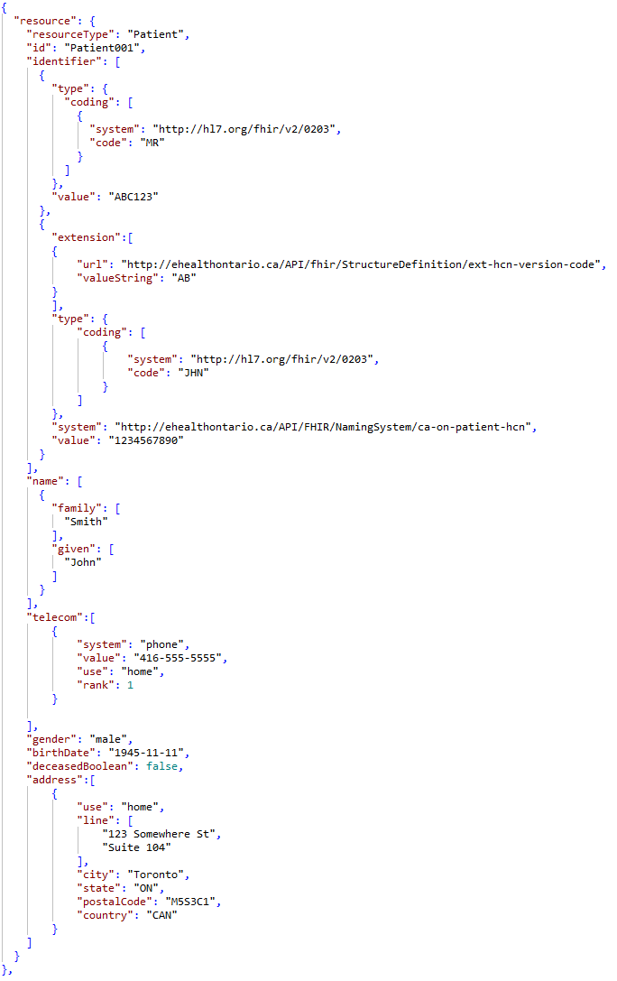

Identifier
This field must contain at least one repetition identifying the patient. These repetitions must follow these rules:
- All messages must contain at least one repetition patient identifier with an identifier type code of MR (MRN).
- A provincial health number (e.g. OHIP number or other province health card number) must also be sent provided the patient has one.
Name | Card. | Type | RP# | Len | Code Tbl# | Description | Sample Data
Identifier |  | Element
extension | O | extension | 1 | - | - | Extension used to contain the HCN Version code should one be necessary.
Type | R | coding | 1 | - | - | Categorization of the type of identifier being presented such as an MRN or HCN.
system | C | URI | 0..1 | - | 0020 | Only present for Health Card Numbers (JHN Type)  URI reference to the system in which value was assigned. This is typically used to specify the URI for the associated Health Ministry such as OHIP | http://ehealthontario.ca/API/FHIR/NamingSystem/ca-on-patient-hcn
value | R | string | 1 | 20 | - | Actual identifier value such as the MRN or HCN number. (HCN Version code should not be present here) | MR01234  or  1234567897

Identifier.Extension
This component must contain the check digit for the identifier, if one exists. If the identifier is an OHIP number, this field must contain the version code, if one is present.

Name | Card. | Type | RP# | Len | Code Tbl# | Description | Sample Data
Extension | O | Element | 1 | - | -
url | R | uri | 1 | - | - | FIXED VALUE: URI associated with the extension use. In this case this is a hardcoded value. | http://ehealthontario.ca/API/fhir/StructureDefinition/ext-identifier-hcn-version-code
valueString | R | string | 1 | - | - | Health Card Number version code. | AB

Identifier.Type.coding
The Identifier Type and subsequent coding element are designed to provide categorization of the type of identifier being provided such as a Jurisdictional Health Card Number such as OHIP or an internal facility Medical Record Number.

Name | Card. | Type | RP# | Len | Description | Sample Data
Type.coding
system | R | reference | 1 | - | URI reference to the coding system being used in the code element. | http://hl7.org/fhir/v2/0203
code | R | string | 1 | - | Specific code to be used within the coding system identified. | JHN or MR

Code: This component must identify which type of identifier this field repetition contains. For HRM purposes the following identifier types should be provided:

MR = Medical Record Number
JHN = Health Card Number.

Name
This component must contain the patient’s name. For HRM purposes the clinicians are expecting to receive the patient’s legal name.

Name | Card. | Type | RP# | Len | Code Tbl# | Description | Sample Data
Name |  | Element
Family | R | String | 1 | 50 | - | Patient’s last name | Smith
Given | R | String | 1 | 50 | - | Patient’s first name | John

Telecom
While the telecom element itself is optional, it should be noted that if the element itself is present. All sub elements are required.

Name | Card. | Type | RP# | Len | Code Tbl# | Description | Sample Data
telecom |  | Element
System | R | Code | 1 | - | 0004 | Telecommunications form for contact point | phone
Value | R | String | 1 | 25 | - | Actual contact value | (416)555-1234
Use | R | Code | 1 | - | 0005 | Purpose of this contact method. | home
Rank | O | PositiveInt | 1 | - | - | Specify preferred order of use (1 = highest) for all telecom methods. | 1

System: For HRM purposes the only contact information that should be provided within the message is the patient’s phone number.

Value: This component contains the patient’s phone number.

Use: The use identifies the purpose of this contact point; for HRM purposes this should always reflect a home phone number.

Rank: An ordering of telecom repetitions to determine the contact method preference.

Gender
This field must contain the gender that the patient is considered to have for administration and record keeping purposes.

Values for administrative sex should be drawn from the following list: male | female | other | unknown

Birth Date
This field must contain the date/time of birth of the patient. This is a required field for HRM purposes.

Deceased Boolean
This field indicates whether the individual is deceased or not. Valid values include true or false. This element should only be present if the deceasedDateTime element is absent.

Deceased Date Time
If recorded in the sending system, this field must contain the date and time of the patient’s death with as much precision as is known. This element should only be present if the deceasedboolean element is absent.

Address
This component must contain the patient’s home address.
Name | Card | Type | RP# | Len | Code Tbl# | Description | Sample Data
Address |  | Element
Use | R | Code | 1 | - | 0007 | The Purpose of this address | Home
Line | O | String | 0..1 | 50 | - | Should include street name, number, direction & P.O. Box etc. | 1 First Avenue
City | O | String | 0..1 | 80 | - | Identifies the name of city, town etc. | North York
State | O | String | 0..1 | 2 | 0016 | Identifies the sub-unit of country. | ON
PostalCode | O | String | 0..1 | 10 | 0021 | Includes the postal code or ZIP code (include ZIP+4) for the address. Please see code table for validation rules.) | M3C4M5
Country | O | string | 0..1 | 3 | 0018 | Subset of Country designations as per ISO-3166-1 Alpha-3 standard. | CAN

Use: This component identifies the address purpose. For HRM purposes only the home address should be provided.

Line: Should include street name, number, direction & P.O. Box etc.

City: Identifies the name of city, town etc.

State: Identifies the sub-unit of country. Reference Code Table 0016

Postal Code: Includes the postal code or ZIP code (include ZIP+4) for the address. Please see code table 0021 for validation rules.)
Country: Values should align to ISO-3166-1 Alpha-3 letter codes. Reference Code Table 0018

Diagnostic Order
The Diagnostic Order resource outlines the request for a diagnostic service.

Element Name | Card | Type | RP# | Len | Code Tbl# | Description | Sample Data
DiagnosticOrder |  | DomainResource
Id | R | Id | 1 | 64 | - | Internal identifier used within the message as a reference to other resources. This must be unique per resource type. | Order001
Orderer | R | Reference | 1 | - | - | The practitioner that holds legal responsibility for ordering the investigation
Identifier | O | Identifier | 1 | - | - | Identifiers assigned to this order instance by the orderer and/or the receiver and/or order fulfiller
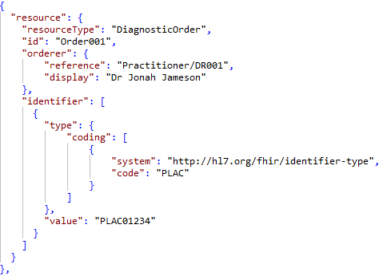

Orderer
This field contains the identity of the provider who ordered this result, if applicable. This component includes the reference ID used within the Practitioner resource to identify the correct practitioner to retrieve additional details regarding the clinician (e.g., first and last name).

Name | Card. | Type | RP# | Len | Code Tbl# | Description | Sample Data
Order
reference | R | string | 1 | - | - | A reference to the Practitioner resource that holds legal responsibility for ordering the investigation. | Practitioner/DR001
display | O | string | 1 | - | - | Optional plain text representation of the assigning authority. | Dr John Smith

Identifier
This field contains the requisition identifier; the identifier associated with the person or service that requests or places an order.
Name | Card. | Type | RP# | Len | Code Tbl# | Description | Sample Data
Identifier |  | Element
Type.coding | R | coding | 1 | - | - | Identifier type coding
value | R | string | 1 | 50 | - | Diagnostic order number associated with this request | PLAC01234

Value: Includes the requisition order number as generated by the information system.

Identifier.Type.coding
The Identifier Type and subsequent coding element are designed to provide categorization of the type of identifier being provided such as a Jurisdictional Health Card Number such as OHIP or an internal facility Medical Record Number.

Name | Card. | Type | RP# | Len | Code Tbl# | Description | Sample Data
Type.coding
system | R | reference | 1 | - | - | FIXED VALUE: URI reference to the coding system being used in the code element. | http://hl7.org/fhir/identifier-type
code | R | string | 1 | - | - | FIXED VALUE: Specific code to be used within the coding system identified. | PLAC

Coding System: The coding system is dependent on the type of identifier being provided, for the requisition identifier the coding system should be http://hl7.org/fhir/identifier-type

Code: This component must identify which type of identifier this field repetition contains. The requisition order should be identified as PLAC

DiagnosticReport
The Diagnostic Report contains the findings and interpretation of diagnostic tests performed on patients. The report includes clinical context such as requesting and provider information, and some mix of atomic results, textual and coded interpretations, and formatted representation of diagnostic reports

Element Name | Card | Type | RP# | Len | Code Tbl# | Description | Sample Data
DiagnosticReport |  | DomainResource
Id | R | Id | 1 | 64 | - | Internal identifier used within the message as a reference to other resources. This must be unique per resource type | Report001
extension | C | Extension | 1 | - | - | Optional extension field to specify urgency of this report
Identifier | R | Identifier | 1 | - | - | The local ID assigned to the report by the order filler, usually by the Information System of the diagnostic service provider
Status | R | code | 1 | - | 0009 | The status of the diagnostic report as a whole | final
Category | R | CodeableConcept | 1 | - | 0010 | A code that classifies the clinical discipline, department or diagnostic service that created the report
Code | R | CodeableConcept | 1 | - | - | Name/Code for this diagnostic report as presented within the LOINC code system.
EffectiveDateTime | R | dateTime | 1 | - | 0021 | The time the observed values are valid from. (Date/time that the observations were made) | 2017-01-01T01:23:45-05:00
Issued | R | Instant | 1 | - | 0021 | The date and time that this version of the report was released from the source diagnostic service. | 2017-01-02T12:23:45-05:00
Performer | R | Reference | 1 | - | - | The Clinician responsible for the diagnostic content of this report.
Request | R | Reference | 1 | - | - | Reference to the DiagnosticOrder details associated with this report.
Conclusion | O | String | 0..1 | - | - | Concise and clinically contextualized narrative interpretation of the diagnostic report including diagnosis information. | Elevated LDL
CodedDiagnosis | O | CodeableConcept | 0…10 | - | - | SNOMED-CT representation of diagnosis information related to the report.
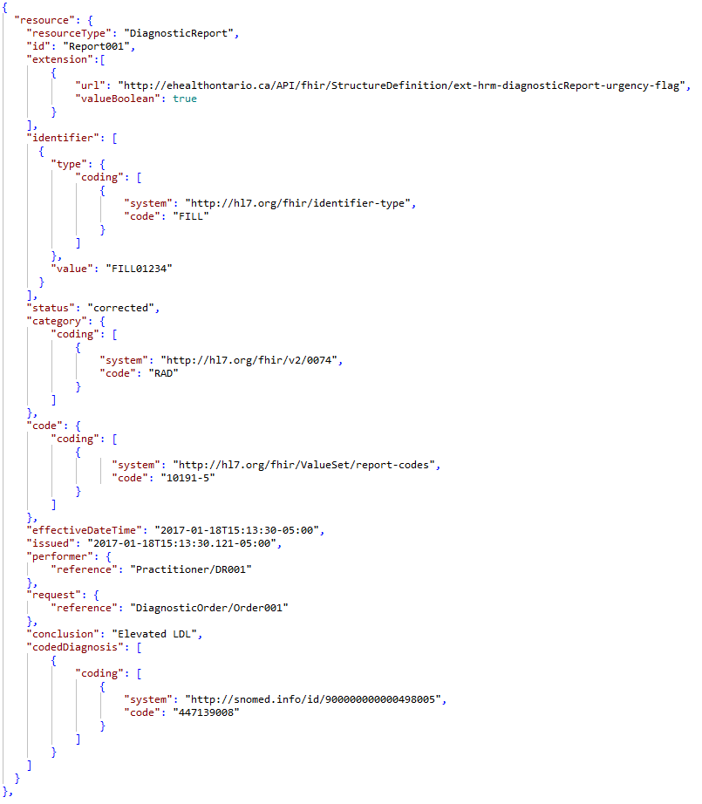

Extension
This component is utilized to designate the urgency of the report attached. This element should only be included if the Urgency flag is set to TRUE.

Name | Card. | Type | RP# | Len | Code Tbl# | Description | Sample Data
Extension |  | Element
url | R | uri | 1 | - | - | FIXED VALUE: URI associated with the extension use. In this case this is a hardcoded value. | http://ehealthontario.ca/API/fhir/StructureDefinition/ext-hrm-diagnosticReport-urgency-flag
valueBoolean | R | boolean | 1 | - | - | Health Card Number version code. | true

Identifier
This field contains the requisition identifier; the identifier associated with the person or service that requests or places an order.
Name | Card. | Type | RP# | Len | Code Tbl# | Description | Sample Data
Identifier |  | Element
Type.coding | R | coding | 1 | - | - | Identifier type coding
value | R | string | 1 | 50 | - | Diagnostic order number associated with this request | FILL01234

Value: Includes the requisition order number as generated by the information system.

Identifier.Type.coding
The Identifier Type and subsequent coding element are designed to provide categorization of the type of identifier being provided such as a Jurisdictional Health Card Number such as OHIP or an internal facility Medical Record Number.

Name | Card. | Type | RP# | Len | Code Tbl# | Description | Sample Data
Type.coding
system | R | reference | 1 | - | - | URI reference to the coding system being used in the code element. | http://hl7.org/fhir/identifier-type
code | R | string | 1 | - | - | Specific code to be used within the coding system identified. | FILL

Coding System: The coding system is dependent on the type of identifier being provided, for the requisition identifier the coding system should be http://hl7.org/fhir/identifier-type

Code: This component must identify which type of identifier this field repetition contains. The requisition order should be identified as FILL

Status
A required field that indicates the current completion state of the document / result. This field must contain one of the following values which will be translated to the following for EMR vendors:

Category.Coding
Category enables contributors to provide granular content to HRM to specify key details about Diagnostic Imaging/Diagnostic Tests (DI) where there may be one or more modalities and their corresponding procedure(s) reported.
For HRM Only: This information is passed on to the recipient EMRs to assist them in categorizing reports received from the hospital or specialty clinic.

Name | Card | Type | RP# | Len | Code Tbl# | Description | Sample Data
Category.Coding |  | Element
System | R | uri | 1 | - | - | URI reference to the coding system being used in the code element. | http://hl7.org/fhir/v2/0074
Code | R | code | 1 | 3 | 0010 | Specific code to be used within the coding system identified. | RAD

System: The coding system is dependent on the type of identifier being provided, for the category the coding system should be http://hl7.org/fhir/v2/0074

Code: When providing the DI modality, the value should align with codes from the URI for the system (e.g., RAD, OUS, etc.)

Code.Coding
This field represents the mnemonic/abbreviation for the report type.

Name | Card. | Type | RP# | Len | Code Tbl# | Description | Sample Data
Code.Coding
System | R | uri | 1 | - | - | URI reference to the coding system being used in the code element. | http://loinc.org
Code | R | code | 1 | - | - | Specific code to be used within the coding system identified. | 10191-5

System: As per FHIR standards the coding system should be http://loinc.org

Code: This value set includes all the LOINC codes which relate to Diagnostic Observations and as such the coded value should be drawn from this list.

EffectiveDateTime
This field contains the most relevant date/time for reports and observations.

For Medical Record Reports Types (e.g. Consult Reports), it contains the dictated date/time. If a Medical Record report is being corrected, it contains the time that the document was last corrected.
For diagnostic images, it contains the dates and times of when the observations were taken, and corresponds directly with the procedures and sub-procedures listed within the category and code fields.

Issued
This field indicates the date and time that this version of the report was released from the source diagnostic service.

Performer
This field must contain the identity of the attending doctor for the patient visit, if appropriate and available. To capture the clinician this component should include the clinicians CPSO or CNO number and reference the Practitioner resource for additional details regarding the attending doctor (e.g., first and last name). For example:

Name | Card. | Type | RP# | Len | Code Tbl# | Description | Sample Data
Performer
reference | R | string | 1 | - | - | A reference to the Practitioner resource that holds legal responsibility for performing the investigation. | Practitioner/DR001
display | O | string | 0..1 | - | - | Optional plain text representation of the assigning authority. | Dr John Smith

Request
Reference to the Diagnostic Order that this report fulfills
Name | Card. | Type | RP# | Len | Code Tbl# | Description | Sample Data
Request
reference | R | string | 1 | - | - | A reference to the Practitioner resource that holds legal responsibility for performing the investigation. | diagnosticOrder/Order001

Conclusion
The conclusion should capture a concise and clinically contextualized narrative interpretation of the diagnostic report.

CodedDiagnosis.Coding
The SNOMED-CT Canadian Edition represented diagnostic code associated with the enclosed report. This is the Canada Health Infoway curated version which includes the Canadian extension added to the SNOMED-CT International Edition.

Name | Card. | Type | RP# | Len | Code Tbl# | Description | Sample Data
Coding |  | Element
System | R | uri | 1 | - | - | URI reference to the coding system being used in the code element. | http://snomed.info/id/900000000000498005
Code | R | code | 1 | - | - | Specific code to be used within the coding system identified. | 447139008

Document Manifest
The document manifest resource defines a set of documents.
Element Name | Card | Type | RP# | Len | Code Tbl# | Description | Sample Data
DocumentManifest
id | R | Id | 1 | - | - | Internal identifier used within the message as a reference to other resources. This must be unique per resource type. | Document001
Recipient | R | Reference | 1…20 | - | - | A practitioner for which this set of documents is intended
Author | R | Reference | 1 | - | - | Identifies who is responsible for creating the manifest, and adding documents to it
Status | R | Code | 1 |  | 0015 | The status of this document manifest | current
Content | R | Content | 1 |  | - | Document content attachments related to this message.
Related | R | Reference | 1 |  | - | Reference to the corresponding DiagnosticReport associated with this document.

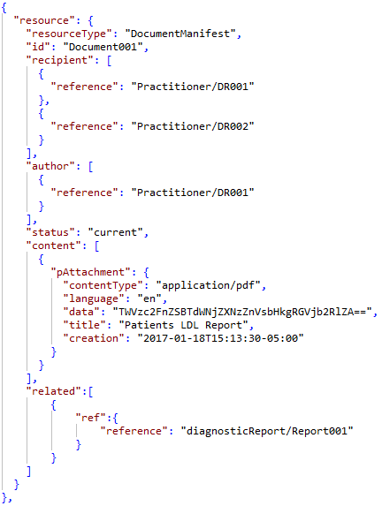

Recipient
This field contains information designating the specific recipients of electronic reports. To capture the report recipients this component should include the clinician’s ID number assigned within the Practitioner resource which will include additional details regarding the recipient (e.g., first and last name).
Name | Card. | Type | RP# | Len | Code Tbl# | Description | Sample Data
Recipient
reference | R | string | 1 | - | - | A reference to the Practitioner resource that holds legal responsibility for performing the investigation. | Practitioner/DR001
display | O | string | 0..1 | - | - | Optional plain text representation of the assigning authority. | Dr John Smith

Author
Identifies who is responsible for creating the manifest, and adding documents to it
Name | Card. | Type | RP# | Len | Code Tbl# | Description | Sample Data
Author
reference | R | string | 1 | - | - | A reference to the Practitioner resource that holds legal responsibility for performing the investigation. | Practitioner/DR002
display | O | string | 0..1 | - | - | Optional plain text representation of the assigning authority. | Dr Bob Doe

Status
The status of this document manifest as represented in Code Table 0015

Content.pAttachment
This field contains the value or text of the patient-related observation or documents.

Name | Card. | Type | RP# | Len | Code Tbl# | Description | Sample Data
Content.pAttachment |  | Element
contentType | R | Code | 1 | - | 0019 | MIME type associated with the base64 encoded data based on RFC 4648 | application/pdf
language | O | Code | 0..1 | - | - | ISO 639-1 representation of the language in which the document was written.  Currently only English and French are supported. | en  Or  fr
data | R | Base64Binary | 1 | - | - | Base64 encoded binary of the report content that has been attached within the message as per RFC 4648
title | O | String | 0..1 | - | - | Title for the attached document. | X-ray right leg
Creation | R | dateTime | 1 | - | 0021 | Date that the attachment was created | 2017-01-01T00:00:00-05:00

Transmitting Binary Contents (Scanned Images, PDFs, etc.)
The CDR supports the storage of binary attachments as a part of a document. This may serve several purposes (the following list is only to provide examples; it is not an exclusive list):
- A PDF document or Microsoft Word document may be transmitted which contains the entire contents of a report
- An image file can be transmitted which supplements the contents of a report
- A diagram can be transmitted which explains a portion of a report
- A sound file can be transmitted which provides interpretation
- An HTML document can be transmitted which contains the body of a report
Binary content is transmitted using the encapsulated data (ED) HL7 data type. To be transmitted in an FHIR message, binary contents must be Base 64 encoded. See the following URL for a description of Base 64 encoding: http://en.wikipedia.org/wiki/Base64

Related.Ref
Reference to the diagnostic report resource that this attachment is related too.
Name | Card. | Type | RP# | Len | Code Tbl# | Description | Sample Data
Related.Ref |  | Element
Reference | R | String | 1 | - | - | Reference to the diagnostic report that this attachment documents. | diagnosticReport/Report001

Encounter
The Encounter resource describes an interaction between a patient and healthcare provider(s) for the purpose of providing healthcare service(s) or assessing the health status of a patient.

Element Name | Card | Type | RP# | Len | Code Tbl# | Description | Sample Data
Encounter
Id | R | Id | 1 | - | - | Internal identifier used within the message as a reference to other resources. This must be unique per resource type. | Visit001
Identifier | R | Identifier | 1 | - | - | Identifier(s) by which this encounter is known. Visit Number
Status | R | Code | 1 | - | 0011 | Current state or status of the encounter | finished
Class | R | Code | 1 | - | 0012 |  | outpatient
Period | R | Period | 1 | - | - | The start and end time of the encounter
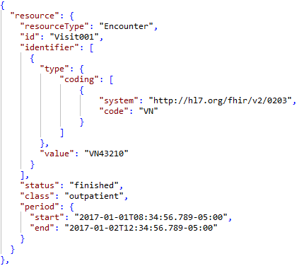

Identifier
This field contains the requisition identifier; the identifier associated with the encounter or visit.
Name | Card. | Type | RP# | Len | Code Tbl# | Description | Sample Data
Identifier |  | Element
Type.coding | R | coding | 1 | - | - | Identifier type coding
value | R | string | 1 | 50 | - | Diagnostic order number associated with this request | VN43210

Value: Includes the requisition order number as generated by the information system.

Identifier.Type.coding
The Identifier Type and subsequent coding element are designed to provide categorization of the type of identifier being provided such as a Jurisdictional Health Card Number such as OHIP or an internal facility Medical Record Number.

Name | Card. | Type | RP# | Len | Code Tbl# | Description | Sample Data
Type.coding
system | R | reference | 1 | - | - | URI reference to the coding system being used in the code element. | http://hl7.org/fhir/v2/0203
code | R | string | 1 | - | - | Specific code to be used within the coding system identified. | VN

Status
The status component defines the state of the encounter. The valid values for this element can be found in Code Table 0011.
For the majority of HRM reports the encounter status is expected to be finished.

Class
This component should contain the classification of the encounter. The valid values for this element can be found in Code Table 0012.

Period
This component includes the start and end time of the encounter. The end time will be considered the discharge date and time.
Name | Card. | Type | RP# | Len | Code Tbl# | Description | Sample Data
Period
start | O | dateTime | 0…1 | - | 0021 | Admit DateTime of the encounter | 2017-01-01T08:34:56-05:00
end | R | dateTime | 1 | - | 0021 | Discharge DateTime of the encounter | 2017-01-02T12:34:56-05:00

Practitioner
A person who is directly or indirectly involved in the provisioning of healthcare.

Element Name | Card | Type | RP# | Len | RP# | Description | Sample Data
Practitioner
Id | R | Id | 1 | 64 | - | Unique Identifier for the practitioner resource within the FHIR construct (NOT the CPSO/CNO identifier) | DR001
Identifier | R | Identifier | 1 | - | - | Identifier construct to contain the Clinician’s college issued identifier
Name | R | HumanName | 1 | - | - | Clinician’s First/Last Name
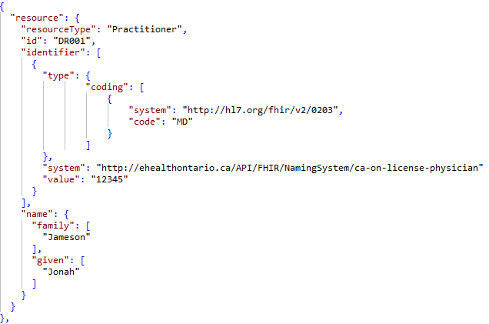

Identifier
This field contains the requisition identifier; the identifier associated with the encounter or visit.
Name | Card. | Type | RP# | Len | Code Tbl# | Description | Sample Data
Identifier |  | Element
Type.coding | R | coding | 1 | - | - | Identifier type coding
System | R | URI | 1 | - | 0017 | URI associated with the regulatory body the practitioner is authorized by | http://ehealthontario.ca/API/FHIR/NamingSystem/ca-on-license-physician
value | R | string | 1 | 50 | - | Diagnostic order number associated with this request | 12345

Value: Includes the requisition order number as generated by the information system.

Identifier.Type.coding
The Identifier Type and subsequent coding element are designed to provide categorization of the type of identifier being provided such as a Jurisdictional Health Card Number such as OHIP or an internal facility Medical Record Number.

Name | Card. | Type | RP# | Len | Code Tbl# | Description | Sample Data
Type.coding
system | R | reference | 1 | - | - | FIXED Value: URI reference to the coding system being used in the code element. | http://hl7.org/fhir/v2/0203
code | R | string | 1 | - | - | Specific code to be used within the coding system identified. | MD  or  NP

Coding System: The coding system is dependent on the type of identifier being provided, for the requisition identifier the coding system should be http://hl7.org/fhir/v2/0203

Code: This component must identify which type of identifier this field repetition contains.

Name
This component must contain the practitioner’s name.

Element Name | Card | Type | RP# | Len | Code Tbl# | Description | Sample Data
Name
Family | R | String | 1 | 50 | - | Clinician’s Last Name | Smith
Given | R | String | 1 | 50 | - | Clinician’s First Name | John

Response Messages

Bundle
The message bundle is the root of all messages to which all resources link up.
Name | Card | Type | RP# | Len | Description | Sample Data
Bundle | R | DomainResource | - | - | Contains a collection of resources  entry
id | R | id | 1 | 64 | Unique Bundle ID | 42128718-5199-42d0-8ad2-90623ef534d3
Type | R | Coding | 1 | - | Bundle type. Default: message | message
entry | R | BackboneElement | 1 | - | Entry in the bundle - will have a resource, or information  must be a resource unless there's a request or response
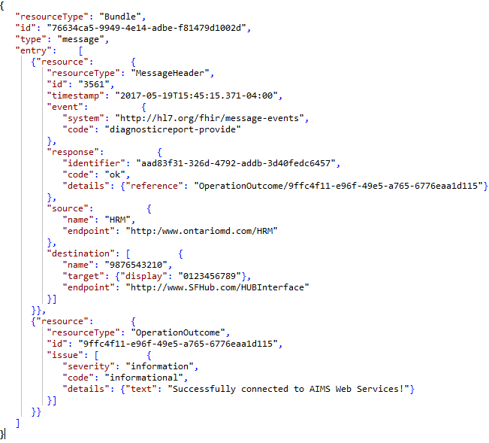

entry
The entry element is a repeating element which can contain only a single resource element and subsequent FHIR resource structure below. The possible sub elements are constrained to HRM FHIR specific elements only. All sub elements must exist within the message at least once and full definitions can be found in subsequent sections of this document.

Element Name | Card | Type | RP# | Len | Description | Sample Data
entry |  | DomainResource | 1 | - | Contains a collection of resources entry. The minimum number of repetitions is 7 with the expectation of at least 1 of each subelement
resource | R | Resource | 2 | - | Entry in the bundle - will have a resource, or information  must be a resource unless there's a request or response  The message response will always consist of 2 resources. | “resourceType”:”MessageHeader”

resource
The resource element is the parent to all FHIR resources contained within the message bundle and must contain a minimum of 1 instance of each. The available FHIR resources are as follows:

ResourceTypes | RP# | Description
MessageHeader | 1..1 | Data related to the message exchange
Operation Outcome | 1..1 | Operation ACK or NACK response details including error details (if applicable).

Message Header
MessageHeader is the header for a message exchange that is either requesting or responding to an action. The reference(s) that are the subject of the action as well as other information related to the action are typically transmitted in a bundle in which the MessageHeader resource instance is the first resource in the bundle. The tables below define the various data elements that should be provided within the Message Header.
Name | Card. | Type | RP# | Len | Code Tbl# | Description | Sample Data
MessageHeader |  |  |  |  |  | A resource that describes a message that is exchanged between systems
id | R | Id | 1 | 64 | - | Unique Message Header ID.  This is utilized as the Message Control ID and will be used as the identifier in the message response | 297
timestamp | R | instant | 1 | - | 0021 | Time that the message was sent from the originating system to HRM. | 2017-01-09T11:36:55-05:00
event | R | Coding | 1 | - | - | Code for the event this message represents
response | R | BackboneElement | 1 | - | - | The response details as references from the original message sent and referenced to the operation outcome
source | R | BackboneElement | 1 | - | - | Message Source Application
destination | R | BackboneElement | 1 | - | - | Message Destination Application(s)
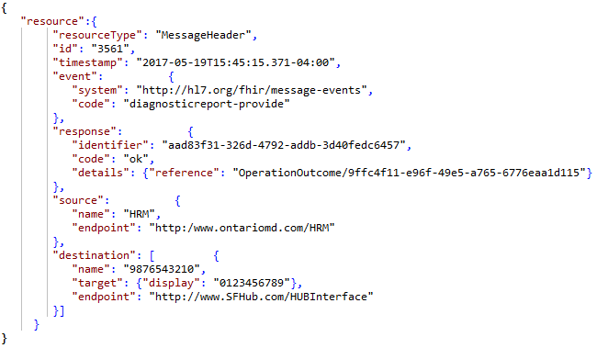

Id
Message unique identifier for this resource. In the case of the message header, this id is utilized as the message control ID that will be included within the message response.

Timestamp
This field must contain the date/time the message was created, including GMT offset such as:
2017-01-09T11:36:55-05:00

Event.coding
This field must contain the code for the event this message represents. For HRM purposes only “diagnosticreport-provide” events should be sent for report delivery.

Name | Card. | Type | RP# | Len | Code Tbl# | Sample Data
Event.Coding | R | Element |  | -
system | R | uri | 1 | - | - | http://hl7.org/fhir/message-events
code | R | code | 1 | - | 0001 | diagnosticreport-provide

Response
Name | Card. | Type | RP# | Len | Code Tbl# | Description | Sample Data
response | R |  |  | -
identifier | R | id | 1 | 1..64 | - | Reference to the original messages ID within the MessageHeader resource. | aad83f31-326d-4792-addb-3d40fedc6457
code | R | code | 1 | - | 0022 | Response type | ok
details | R | Reference | 1 | - | - | Reference to the OperationOutcome resource that contains the full response details.

Response.details

Name | Card. | Type | RP# | Len | Code Tbl# | Description | Sample Data
details
reference | R | string | 1 | - | - | Reference to response details | OperationOutcome/cf244b87-9e5c-469d-8aa9-a671e8c2b2bc

Source
The sending facility for HRM is the legal HSP that takes full responsibility for sending the message. The source for this unique identifier is the Provider Registry number assigned to your facility by eHealth Ontario.

Name | Card. | Type | RP# | Len | Code Tbl# | Sample Data
Source | R | Element
endpoint | R | uri | 1 | - | - | http://www.ontariomd.com

Destination
The purpose of this segment is to denote the intermediary system and destination application which the message is intended. OntarioMD will inform your sending facility what to populate this field with.

Name | Card. | Type | RP# | Len | Code Tbl# | Sample Data
Destination | R | Element
name | R | string | 1 | - | - | 1234567890  OR  0987654321
target | R | Reference | 1 | - | -
endpoint | R | uri | 1 | - | - | http://10.10.10.10:12345  OR  http://www.SFHub.com/HubInterface

Name: Human-readable name for the target system; in this case HRM.
Target: Identifies the target end system, in this case HRM will always be the target.
Endpoint: Indicates where the message should be routed to. This will indicate the URI for either HRM or the Intermediary HUB being routed through.

Destination.Target
The target element contained within the Destination information is always defined as HRM as the true target destination and must contain the HRM URI endpoint data.

Name | Card. | Type | RP# | Len | Code Tbl# | Description | Sample Data
Target
display | R | string | 1 | - | - | Display name for target system. | OMD Health Sciences

Operation Outcome
Operation Outcomes are sets of error, warning and information messages that provide detailed information about the outcome of some attempted system operation. They are provided as a direct system response, or component of one, where they provide information about the outcome of the operation.
Element Name | Card | Type | RP# | Len | Code Tbl# | Description | Sample Data
Operation Outcome |  |  |  |  |  | A resource that describes a message that is exchanged between systems
id | R | Id | 1 | 64 | - | Internal identifier used within the message as a reference to other resources. This must be unique per resource type | cf244b87-9e5c-469d-8aa9-a671e8c2b2bc
issue | R | BackboneElement | 1..* | - | - | A single issue associated with the action
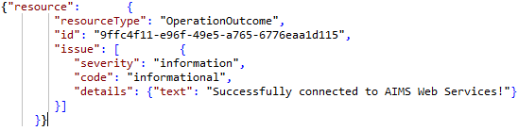

issue
A repeating element that will provide details as to the response of the submitted message. This element will either contain details that the message was received successfully or will provide details as to why the message was rejected.
Name | Card | Type | RP# | Len | Code Tbl# | Description | Sample Data
issue
Severity | R | string | 1 | - | 0023 | How the issue affects the success of the action. | error
Code | R | Reference | 1 | - | 0024 | A code that describes the type of issue. | invalid
details | R | codeableconcept | 1 | - | -

issue.details

Name | Card. | Type | RP# | Len | Code Tbl# | Description | Sample Data
details
text | R | reference | 1 | - | - | Additional details about the error | Patient Resource must be present and only exists once.

Message Example
{
"resourceType": "Bundle",
"id": "PKG1-UC1-2-1",
"type": "message",
"entry": [
{
"resource": {
"resourceType": "MessageHeader",
"id": "aad83f31-326d-4792-addb-3d40fedc6457",
"timestamp": "2017-01-18T15:13:30.121-05:00",
"event": {
"system": "http://hl7.org/fhir/message-events",
"code": "diagnosticreport-provide"
},
"source": {
"name": "0123456789",
"endpoint": "http://10.10.10.10:12345"
},
"destination": [
{
"name": "9876543210",
"endpoint": "http://www.SFHub.com/HUBInterface"
}
]
}
},
{
"resource": {
"resourceType": "Patient",
"id": "Patient001",
"identifier": [
{
"type": {
"coding": [
{
"system": "http://hl7.org/fhir/v2/0203",
"code": "MR"
}
]
},
"value": "ABC123"
},
{
"extension":[
{
"url": "http://ehealthontario.ca/API/fhir/StructureDefinition/ext-identifier-hcn-version-code",
"valueString": "AB"
}
],
"type": {
"coding": [
{
"system": "http://hl7.org/fhir/v2/0203",
"code": "JHN"
}
]
},
"system": "http://ehealthontario.ca/API/FHIR/NamingSystem/ca-on-patient-hcn",
"value": "1234567890"
}
],
"name": [
{
"family": [
"Smith"
],
"given": [
"John"
]
}
],
"telecom":[
{
"system": "phone",
"value": "416-555-5555",
"use": "home",
"rank": 1
}

],
"gender": "male",
"birthDate": "1945-11-11",
"deceasedBoolean": false,
"address":[
{
"use": "home",
"line": [
"123 Somewhere St",
"Suite 104"
],
"city": "Toronto",
"state": "ON",
"postalCode": "M5S3C1",
"country": "CAN"
}
]
}
},
{
"resource": {
"resourceType": "DiagnosticOrder",
"id": "Order001",
"orderer": {
"reference": "Practitioner/DR001",
"display": "Dr Jonah Jameson"
},
"identifier": [
{
"type": {
"coding": [
{
"system": "http://hl7.org/fhir/identifier-type",
"code": "PLAC"
}
]
},
"value": "PLAC01234"
}
]
}
},
{
"resource": {
"resourceType": "DiagnosticReport",
"id": "Report001",
"extension":[
{
"url": "http://ehealthontario.ca/API/fhir/StructureDefinition/ext-hrm-diagnosticReport-urgency-flag",
"valueBoolean": true
}
],
"identifier": [
{
"type": {
"coding": [
{
"system": "http://hl7.org/fhir/identifier-type",
"code": "FILL"
}
]
},
"value": "FILL01234"
}
],
"status": "corrected",
"category": {
"coding": [
{
"system": "http://hl7.org/fhir/v2/0074",
"code": "RAD"
}
]
},
"code": {
"coding": [
{
"system": "http://loinc.org",
"code": "10191-5"
}
]
},
"effectiveDateTime": "2017-01-18T15:13:30-05:00",
"issued": "2017-01-18T15:13:30.121-05:00",
"performer": {
"reference": "Practitioner/DR001"
},
"request": {
"reference": "DiagnosticOrder/Order001"
},
"conclusion": "Elevated LDL",
"codedDiagnosis": [
{
"coding": [
{
"system": "http://snomed.info/id/900000000000498005",
"code": "447139008"
}
]
}
]
}
},
{
"resource": {
"resourceType": "DocumentManifest",
"id": "Document001",
"recipient": [
{
"reference": "Practitioner/DR001"
},
{
"reference": "Practitioner/DR002"
}
],
"author": [
{
"reference": "Practitioner/DR001"
}
],
"status": "current",
"content": [
{
"pAttachment": {
"contentType": "application/pdf",
"language": "en",
"data": "TWVzc2FnZSBTdWNjZXNzZnVsbHkgRGVjb2RlZA==",
"title": "Patients LDL Report",
"creation": "2017-01-18T15:13:30-05:00"
}
}
],
"related":[
{
"ref":{
"reference": "diagnosticReport/Report001"
}
}
]
}
},
{
"resource": {
"resourceType": "Encounter",
"id": "Visit001",
"identifier": [
{
"type": {
"coding": [
{
"system": "http://hl7.org/fhir/v2/0203",
"code": "VN"
}
]
},
"value": "VN43210"
}
],
"status": "finished",
"class": "outpatient",
"period": {
"start": "2017-01-01T08:34:56.789-05:00",
"end": "2017-01-02T12:34:56.789-05:00"
}
}
},
{
"resource": {
"resourceType": "Practitioner",
"id": "DR001",
"identifier": [
{
"type": {
"coding": [
{
"system": "http://hl7.org/fhir/v2/0203",
"code": "MD"
}
]
},
"system": "http://ehealthontario.ca/API/FHIR/NamingSystem/ca-on-license-physician",
"value": "12345"
}
],
"name": {
"family": [
"Jameson"
],
"given": [
"Jonah"
]
}
}
},
{
"resource": {
"resourceType": "Practitioner",
"id": "DR002",
"identifier": [
{
"type": {
"coding": [
{
"system": "http://hl7.org/fhir/v2/0203",
"code": "MD"
}
]
},
"system": "http://ehealthontario.ca/API/FHIR/NamingSystem/ca-on-license-physician",
"value": "54321"
}
],
"name": {
"family": [
"Smith"
],
"given": [
"John"
]
}
}
}
]
}

Code Tables

Table 0001 – Event Code

Code | Definition
MedicationAdministration-Complete | Change the status of a Medication Administration to show that it is complete.
MedicationAdministration-Nullification | Someone wishes to record that the record of administration of a medication is in error and should be ignored.
MedicationAdministration-Recording | Indicates that a medication has been recorded against the patient's record.
MedicationAdministration-Update | Update a Medication Administration record.
admin-notify | Notification of a change to an administrative resource (either create or update). Note that there is no delete, though some administrative resources have status or period elements for this use.
diagnosticreport-provide | Provide a diagnostic report, or update a previously provided diagnostic report.
observation-provide | Provide a simple observation or update a previously provided simple observation.
patient-link | Notification that two patient records actually identify the same patient.
patient-unlink | Notification that previous advice that two patient records concern the same patient is now considered incorrect.
valueset-expand | The definition of a value set is used to create a simple collection of codes suitable for use for data entry or validation. An expanded value set will be returned, or an error message.

Table 0002 – Identifier Use

Code | Definition
usual | The identifier recommended for display and use in real-world interactions.
official | The identifier considered to be most trusted for the identification of this item.
temp | A temporary identifier.
secondary | An identifier that was assigned in secondary use - it serves to identify the object in a relative context, but cannot be consistently assigned to the same object again in a different context.

Table 0003 – Identifier Type Codes

http://hl7.org/fhir/identifier-type

Code | Definition
UDI | A identifier assigned to a device using the Universal Device Identifier framework as defined by FDA
SNO | An identifier affixed to an item by the manufacturer when it is first made, where each item has a different identifier.
SB | An identifier issued by a governmental organization to an individual for the purpose of the receipt of social services and benefits.
PLAC | The identifier associated with the person or service that requests or places an order.
FILL | The Identifier associated with the person, or service, who produces the observations or fulfills the order requested by the requestor.

http://hl7.org/fhir/v2/0203

Code | Display
DL | Driver's license number
PPN | Passport number
BRN | Breed Registry Number
MR | Medical record number
MCN | Microchip Number
EN | Employer number
TAX | Tax ID number
NIIP | National Insurance Payor Identifier (Payor)
PRN | Provider number
MD | Medical License number
DR | Donor Registration Number
VN | Visit Number
LN | License Number

Table 0004 – Contact Point System
Code | Definition
phone | The value is a telephone number used for voice calls. Use of full international numbers starting with + is recommended to enable automatic dialing support but not required.
fax | The value is a fax machine. Use of full international numbers starting with + is recommended to enable automatic dialing support but not required.
email | The value is an email address.
pager | The value is a pager number. These may be local pager numbers that are only usable on a particular pager system.
other | A contact that is not a phone, fax, or email address. The format of the value SHOULD be a URL. This is intended for various personal contacts including blogs, Twitter, Facebook, etc. Do not use for email addresses. If this is not a URL, then it will require human interpretation.

Table 0005 – Contact Point Use
Code | Definition
home | A communication contact point at a home; attempted contacts for business purposes might intrude privacy and chances are one will contact family or other household members instead of the person one wishes to call. Typically used with urgent cases, or if no other contacts are available.
work | An office contact point. First choice for business related contacts during business hours.
temp | A temporary contact point. The period can provide more detailed information.
old | This contact point is no longer in use (or was never correct, but retained for records).
mobile | A telecommunication device that moves and stays with its owner. May have characteristics of all other use codes, suitable for urgent matters, not the first choice for routine business.

Table 0006 – Administrative Gender
Code | Definition
male | Male
female | Female
other | Other
unknown | Unknown

Table 0007 – Address Use
Code | Definition
home | A communication address at a home.
work | An office address. First choice for business related contacts during business hours.
temp | A temporary address. The period can provide more detailed information.
old | This address is no longer in use (or was never correct, but retained for records).

Table 0008 – Address Type
Code | Display | Definition | v3 Map (AddressUse)
postal | Postal | Mailing addresses - PO Boxes and care-of addresses. | =PHYS
physical | Physical | A physical address that can be visited. | =PST
both | Postal & Physical | An address that is both physical and postal.

Table 0009 – Diagnostic Report Status
Code | Definition
registered | The existence of the report is registered, but there is nothing yet available.
partial | This is a partial (e.g. initial, interim or preliminary) report: data in the report may be incomplete or unverified.
final | The report is complete and verified by an authorized person.
corrected | The report has been modified subsequent to being Final, and is complete and verified by an authorized person. New content has been added, but existing content hasn't changed
appended | The report has been modified subsequent to being Final, and is complete and verified by an authorized person. New content has been added, but existing content hasn't changed.
cancelled | The report is unavailable because the measurement was not started or not completed (also sometimes called "aborted").
entered-in-error | The report has been withdrawn following a previous final release.

Table 0010 – Diagnostic Report Category
Code | Description
AU | Audiology
BG | Blood Gases
BLB | Blood Bank
CG | Cytogenetics
CH | Chemistry
CP | Cytopathology
CT | CAT Scan
CTH | Cardiac Catheterization
CUS | Cardiac Ultrasound
EC | Electrocardiac (e.g. EKG, EEC, Holter)
EN | Electroneuro (EEG, EMG,EP,PSG)
GE | Genetics
HM | Hematology
ICU | Bedside ICU Monitoring
IMM | Immunology
LAB | Laboratory
MB | Microbiology
MCB | Mycobacteriology
MYC | Mycology
NMR | Nuclear Magnetic Resonance
NMS | Nuclear Medicine Scan
NRS | Nursing Service Measures
OSL | Outside Lab
OT | Occupational Therapy
OTH | Other
OUS | OB Ultrasound
PF | Pulmonary Function
PHR | Pharmacy
PHY | Physician (Hx. Dx, admission note, etc.)
PT | Physical Therapy
RAD | Radiology
RC | Respiratory Care (therapy)
RT | Radiation Therapy
RUS | Radiology Ultrasound
RX | Radiograph
SP | Surgical Pathology
SR | Serology
TX | Toxicology
VR | Virology
VUS | Vascular Ultrasound
XRC | Cineradiograph

Table 0011 – Encounter Status
Code | Definition
planned | The Encounter has not yet started.
arrived | The Patient is present for the encounter, however is not currently meeting with a practitioner.
in-progress | The Encounter has begun and the patient is present / the practitioner and the patient are meeting.
onleave | The Encounter has begun, but the patient is temporarily on leave.
finished | The Encounter has ended.
cancelled | The Encounter has ended before it has begun.

Table 0012 – Encounter Class
Code | Definition
inpatient | An encounter during which the patient is hospitalized and stays overnight.
outpatient | An encounter during which the patient is not hospitalized overnight.
ambulatory | An encounter where the patient visits the practitioner in his/her office, e.g. a G.P. visit.
emergency | An encounter in the Emergency Care Department.
home | An encounter where the practitioner visits the patient at his/her home.
field | An encounter taking place outside the regular environment for giving care.
daytime | An encounter where the patient needs more prolonged treatment or investigations than outpatients, but who do not need to stay in the hospital overnight.
virtual | An encounter that takes place where the patient and practitioner do not physically meet but use electronic means for contact.
other | Any other encounter type that is not described by one of the other values. Where this is used it is expected that an implementer will include an extension value to define what the actual other type is.

Table 0013 – Practitioner Role
Code
doctor
nurse
pharmacist
researcher
teacher
ict

Table 0014 – Assigning Authority
Code | Meaning
CA | Canada
CA-AB | Alberta
CA-BC | British Columbia
CA-MB | Manitoba
CA-NB | New Brunswick
CA-NF | Newfoundland
CA-NS | Nova Scotia
CA-NT | Northwest Territories
CA-NU | Nunavut
CA-ON | Ontario
CA-PE | Prince Edward Island
CA-QC | Quebec
CA-SK | Saskatchewan
CA-YT | Yukon

Table 0015 – DocumentManifest Status
Code | Display | Definition
current | Current | This is the current reference for this document.
superseded | Superseded | This reference has been superseded by another reference.
entered-in-error | Entered in Error | This reference was created in error.

Table 0016 – Address State
Code | Meaning |  | Code | Meaning |  | Code | Meaning
AB | Alberta |  | FL | Florida |  | NJ | New Jersey
BC | British Columbia |  | GA | Georgia |  | NM | New Mexico
MB | Manitoba |  | GU | Guam |  | NV | Nevada
NB | New Brunswick |  | HI | Hawaii |  | NY | New York
NF | Newfoundland |  | IA | Iowa |  | OH | Ohio
NS | Nova Scotia |  | ID | Idaho |  | OK | Oklahoma
NT | Northwest Territories |  | IL | Illinois |  | OR | Oregon
NU | Nunavut |  | IN | Indiana |  | PA | Pennsylvania
ON | Ontario |  | KS | Kansas |  | PR | Puerto Rico
PE | Prince Edward Island |  | KY | Kentucky |  | RI | Rhode Island
QC | Quebec |  | LA | Louisiana |  | SC | South Carolina
SK | Saskatchewan |  | MA | Massachusetts |  | SD | South Dakota
YT | Yukon |  | MD | Maryland |  | TN | Tennessee
 |  |  | ME | Maine |  | TX | Texas
AK | Alaska |  | MI | Michigan |  | UM | United States Minor Outlying Islands
AL | Alabama |  | MO | Missouri |  | UT | Utah
AR | Arkansas |  | MP | Northern Mariana Islands |  | VA | Virginia
AS | American Samoa |  | MS | Mississippi |  | VI | Virgin Islands, U.S.
CA | California |  | MT | Montana |  | VT | Vermont
CO | Colorado |  | NC | North Carolina |  | WA | Washington
CT | Connecticut |  | ND | North Dakota |  | WI | Wisconsin
DC | District of Columbia |  | NE | Nebraska |  | WV | West Virginia
DE | Delaware |  | NH | New Hampshire |  | WY | Wyoming

Table 0017 – Physician Systems
URI | Meaning
http://ehealthontario.ca/API/FHIR/NamingSystem/ca-on-license-physician | College of Physicians and Surgeons of Ontario
http://ehealthontario.ca/API/FHIR/NamingSystem/ca-ab-license-physician | College of Physicians and Surgeons of Alberta
http://ehealthontario.ca/API/FHIR/NamingSystem/ca-on-license-physician | College of Physicians and Surgeons of British Columbia
http://ehealthontario.ca/API/FHIR/NamingSystem/ca-mb-license-physician | College of Physicians and Surgeons of Manitoba
http://ehealthontario.ca/API/FHIR/NamingSystem/ca-nb-license-physician | College of Physicians and Surgeons of New Brunswick
http://ehealthontario.ca/API/FHIR/NamingSystem/ca-nl-license-physician | College of Physicians and Surgeons of Newfoundland & Labrador
http://ehealthontario.ca/API/FHIR/NamingSystem/ca-ns-license-physician | College of Physicians and Surgeons of Nova Scotia
http://ehealthontario.ca/API/FHIR/NamingSystem/ca-nt-license-physician | Health and Social Services - Government of the Northwest Territories
http://ehealthontario.ca/API/FHIR/NamingSystem/ca-nu-license-physician | Department of Health and Social Services – Government t of Nunavut
http://ehealthontario.ca/API/FHIR/NamingSystem/ca-pe-license-physician | College of Physicians and Surgeons of Prince Edward Island
http://ehealthontario.ca/API/FHIR/NamingSystem/ca-qc-license-physician | Collège des médecins du Québec
http://ehealthontario.ca/API/FHIR/NamingSystem/ca-sk-license-physician | College of Physicians and Surgeons of Saskatchewan
http://ehealthontario.ca/API/FHIR/NamingSystem/ca-yt-license-physician | Yukon Medical Council
http://ehealthontario.ca/API/FHIR/NamingSystem/ca-on-license-nurse | College of Nurses of Ontario
http://ehealthontario.ca/API/FHIR/NamingSystem/ca-ab-license-nurse | College and Association of Registered Nurses of Alberta
http://ehealthontario.ca/API/FHIR/NamingSystem/ca-bc-license-nurse | College of Registered Nurses of British Columbia
http://ehealthontario.ca/API/FHIR/NamingSystem/ca-mb-license-nurse | College of Registered Nurses of Manitoba
http://ehealthontario.ca/API/FHIR/NamingSystem/ca-nb-license-nurse | Nurses Association of New Brunswick
http://ehealthontario.ca/API/FHIR/NamingSystem/ca-nl-license-nurse | Association of Registered Nurses of Newfoundland and Labrador
http://ehealthontario.ca/API/FHIR/NamingSystem/ca-ns-license-nurse | College of Registered Nurses of Nova Scotia
http://ehealthontario.ca/API/FHIR/NamingSystem/ca-nt-license-nurse | Registered Nurses Association of the Northwest Territories and Nunavut
http://ehealthontario.ca/API/FHIR/NamingSystem/ca-nu-license-nurse | Registered Nurses Association of the Northwest Territories and Nunavut
http://ehealthontario.ca/API/FHIR/NamingSystem/ca-pe-license-nurse | Association of Registered Nurses of Prince Edward Island
http://ehealthontario.ca/API/FHIR/NamingSystem/ca-qc-license-nurse | Ordre des infirmières et infirmiers du Québec
http://ehealthontario.ca/API/FHIR/NamingSystem/ca-sk-license-nurse | Saskatchewan Registered Nurses’ Association
http://ehealthontario.ca/API/FHIR/NamingSystem/ca-yt-license-nurse | Yukon Registered Nurses Association

Table 0018 – Countries
Code | Country
CAN | Canada
USA | United States of America
OTH | Other/Undefined

Table 0019 – Document MIME types
Mime Type | Description
text/plain | Represents any document that contains text and is theoretically human readable
application/pdf | PDF encoded document
image/jpeg | JPEG encoded image
image/tiff | TIFF encoded image
image/png | PNG encoded image
image/gif | GIF encoded image
application/rtf | RTF encoded document

Table 0020 – Health Card Provincial Systems
URI | Province
http://ehealthontario.ca/API/FHIR/NamingSystem/ca-on-patient-hcn | Ontario
http://ehealthontario.ca/API/FHIR/NamingSystem/ca-ab-patient-hcn | Alberta
http://ehealthontario.ca/API/FHIR/NamingSystem/ca-bc-patient-hcn | British Columbia
http://ehealthontario.ca/API/FHIR/NamingSystem/ca-mb-patient-hcn | Manitoba
http://ehealthontario.ca/API/FHIR/NamingSystem/ca-nb-patient-hcn | New Brunswick
http://ehealthontario.ca/API/FHIR/NamingSystem/ca-nl-patient-hcn | Newfoundland and Labrador
http://ehealthontario.ca/API/FHIR/NamingSystem/ca-ns-patient-hcn | Nova Scotia
http://ehealthontario.ca/API/FHIR/NamingSystem/ca-nt-patient-hcn | Northwest Territories
http://ehealthontario.ca/API/FHIR/NamingSystem/ca-nu-patient-hcn | Nunavut
http://ehealthontario.ca/API/FHIR/NamingSystem/ca-pe-patient-hcn | Prince Edward Island
http://ehealthontario.ca/API/FHIR/NamingSystem/ca-qc-patient-hcn | Quebec
http://ehealthontario.ca/API/FHIR/NamingSystem/ca-sk-patient-hcn | Saskatchewan
http://ehealthontario.ca/API/FHIR/NamingSystem/ca-yt-patient-hcn | Yukon

Table 0021 - Special Rules
This section defines special rules that apply data type within the following sections. Only constraints of deviations have been included and anything not listed here should be assumed to be the default FHIR or JSON usage rules.

Date Type/Element | Rules | Code Details
DateTime | Time values and GMT offset shall be enforced for all instances of the DateTime data type. | Regex:  (([1-9][0-9]{3})-((0[1-9])|(1[012]))-((0[1-9])|([12][0-9])|(3[01]))T(([01][0-9])|(2[0-3]))(:[0-5][0-9]){2}(\.[0-9]+)?(([\+|\-]((0[0-9])|(1[0-2]))(:[0-5][0-9]))|(\+13(:[0-5][0-9]))|\+14:00|Z))
Instant | GMT offset shall be enforced | Regex:  (([1-9][0-9]{3})-((0[1-9])|(1[012]))-((0[1-9])|([12][0-9])|(3[01]))T(([01][0-9])|(2[0-3]))(:[0-5][0-9]){2}(\.[0-9]+)?(([\+|\-]((0[0-9])|(1[0-2]))(:[0-5][0-9]))|(\+13(:[0-5][0-9]))|\+14:00|Z))
PostalCode | Postal or Zip code associated with the Patient Address | Regex:  (([a-zA-Z][0-9][a-zA-Z][0-9][a-zA-Z][0-9])|[0-9]{5}(-[0-9]{4})?)

Table 0022 – Response Codes

Code | Description
ok | The message was accepted and processed without error.
transient-error | Some internal unexpected error occurred - wait and try again. Note - this is usually used for things like database unavailable, which may be expected to resolve, though human intervention may be required.
fatal-error | The message was rejected because of some content in it. There is no point in re-sending without change. The response narrative SHALL describe the issue.

Table 0023 – Issue Severity
Defining URL: http://hl7.org/fhir/ValueSet/issue-severity
Code | Description
fatal | The issue caused the action to fail, and no further checking could be performed.
error | The issue is sufficiently important to cause the action to fail.
warning | The issue is not important enough to cause the action to fail, but may cause it to be performed suboptimally or in a way that is not as desired.
information | The issue has no relation to the degree of success of the action.

Table 0024 – Issue type
Defining URL: http://hl7.org/fhir/ValueSet/issue-type
Code | Description
invalid | Content invalid against the specification or a profile.
structure | A structural issue in the content such as wrong namespace, or unable to parse the content completely, or invalid json syntax.
required | A required element is missing.
value | An element value is invalid.
invariant | A content validation rule failed - e.g. a schematron rule.
security | An authentication/authorization/permissions issue of some kind.
login | The client needs to initiate an authentication process.
unknown | The user or system was not able to be authenticated (either there is no process, or the proferred token is unacceptable).
expired | User session expired; a login may be required.
forbidden | The user does not have the rights to perform this action.
suppressed | Some information was not or may not have been returned due to business rules, consent or privacy rules, or access permission constraints. This information may be accessible through alternate processes.
processing | Processing issues. These are expected to be final e.g. there is no point resubmitting the same content unchanged.
not-supported | The resource or profile is not supported.
duplicate | An attempt was made to create a duplicate record.
not-found | The reference provided was not found. In a pure RESTful environment, this would be an HTTP 404 error, but this code may be used where the content is not found further into the application architecture.
too-long | Provided content is too long (typically, this is a denial of service protection type of error).
code-invalid | The code or system could not be understood, or it was not valid in the context of a particular ValueSet.code.
extension | An extension was found that was not acceptable, could not be resolved, or a modifierExtension was not recognized.
too-costly | The operation was stopped to protect server resources; e.g. a request for a value set expansion on all of SNOMED CT.
business-rule | The content/operation failed to pass some business rule, and so could not proceed.
conflict | Content could not be accepted because of an edit conflict (i.e. version aware updates) (In a pure RESTful environment, this would be an HTTP 404 error, but this code may be used where the conflict is discovered further into the application architecture.)
incomplete | Not all data sources typically accessed could be reached, or responded in time, so the returned information may not be complete.
transient | Transient processing issues. The system receiving the error may be able to resubmit the same content once an underlying issue is resolved.
lock-error | A resource/record locking failure (usually in an underlying database).
no-store | The persistent store is unavailable; e.g. the database is down for maintenance or similar action.
exception | An unexpected internal error has occurred.
timeout | An internal timeout has occurred.
throttled | The system is not prepared to handle this request due to load management.
informational | A message unrelated to the processing success of the completed operation (examples of the latter include things like reminders of password expiry, system maintenance times, etc.).

